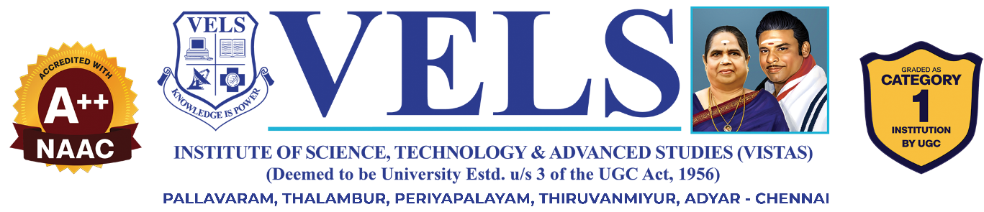
AI Smart Mirror for Skin Analysis and Personalised recommendations

FINAL YEAR

PROJECT PHASE-I REPORT

Submitted by
Meharnisha M (23619219)
Gayisha Rajesh (23619207)
Abdul Alagan (23619201)
in partial fulfilment for the award of the degree of

BACHELOR OF TECHNOLOGY CSE -
ARTIFICIAL INTELLIGENCE AND MACHINE LEARNING



DEPARTMENT OF ARTIFICIAL INTELLIGENCE AND MACHINE LEARNING
SCHOOL OF ENGINEERING
VELS INSTITUTE OF SCIENCE, TECHNOLOGY AND ADVANCED STUDIES (VISTAS)
CHENNAI
OCTOBER 2026
BONAFIDE CERTIFICATE
Certified that this project “AI Smart Mirror for Skin Analysis: A Low-Cost MobileNetV2 System on Raspberry Pi” is the bonafide work of Meharnisha M (23619219), Gayisha Rajesh (23619207), Abdul Alagan (23619201) who carried out the project work under my supervision. Certified further that, to the best of my knowledge, the work reported here does not form part of any other project report or dissertation on the basis of which a degree or award was conferred on an earlier occasion on this or any other candidate.
SIGNATURE OF THE HOD  Dr. K. Ulaga Priya, M.E., Ph.D.  Associate Professor & Head  Department of AI & ML  School of Engineering  VISTAS  Chennai - 600 117 | SIGNATURE OF THE SUPERVISOR  Ms. S. M. Sowmiya, M.E., (Ph.D)  Assistant Professor  Department of AI & ML  School of Engineering  VISTAS  Chennai - 600 117
Submitted for the Project Work and Viva-Voce examination held on ……………… at Vels Institute of Science, Technology and Advanced Studies (VISTAS), Chennai – 600 117.
INTERNAL EXAMINER | EXTERNAL EXAMINER
ACKNOWLEDGEMENT
It is certainly a great delight and proud privilege to acknowledge the help and support I received from the positive minds around me in making this venture a successful one. The infrastructural support with all kinds of lab facilities have been a motivating factor in this completion of project work, all because of Founder & Chairman, Shri. Dr. ISHARI K. GANESH., with great pleasure that I take this opportunity to thank him. I am grateful to our Head of the Department, Dr. K. Ulagapriya., M.E., Ph.D for her continuous support for the project, from initial advice and contacts in the early stages of conceptual inception, and through on-going advice and encouragement to this day. I extend our warmest thanks to my Internal Guide and Project Coordinator, Ms. S. M. Sowmiya, M.E., (Ph.D) who has patiently guided and provided us with invaluable advice and help. I am also thankful to her for coordinating the project work. I would like to express my greatest gratitude to our Staff members, Librarian, and Non-teaching staff members of Computer Centre, who have helped and supported me throughout. Last but not the Least, I wish to thank my parents and my friends for their individual support and interest who has inspired me and encouraged me to go in my own way, without them I would be unable to complete this project.

MEHARNISHA M 23619219
GAYISHA RAJESH 23619207
ABDUL ALAGAN 23619201
TABLE OF CONTENTS
ABSTRACT 7
LIST OF FIGURES 8
LIST OF TABLES 9
LIST OF ABBREVIATIONS 10
INTRODUCTION 11
1.1 General 11
1.2 Problem Description 11
1.3 Existing System 12
1.4 Proposed System 12
1.5 Objectives 13
1.6 Scope of the Project 13
1.7 Contributions 13
1.8 Modules 14
1.9 Summary 14
LITERATURE REVIEW 15
2.1 AI-Based Acne Assessment 15
2.2 Smart Mirror with Fashion Recommendation 16
2.3 Deep Learning for Health Evaluation and Virtual Enhancement 16
2.4 Raspberry Pi Based Smart Mirror 17
2.5 Skincare Product Recommendation 17
2.6 Lightweight Networks and Transfer Learning 18
2.7 Existing Systems and Limitations 19
2.8 Comparative Analysis of the Surveyed Studies 20
2.9 Common Challenges in Image-Based Skin Analysis 21
2.10 Design Implications for This Project 22
2.11 Research Gap 23
2.12 Summary 23
SYSTEM DESIGN 24
3.1 Existing System 24
3.2 Proposed System 24
3.3 System Architecture 24
3.4 Overall Workflow 25
3.5 System Modules 25
3.6 Data Flow 26
3.7 Hardware Requirements 27
3.8 Software Requirements 28
3.9 Summary 28
IMPLEMENTATION AND METHODOLOGY 29
4.1 Hardware Setup and Image Acquisition 29
4.2 Dataset Collection and Class Definition 29
4.3 Image Preprocessing 30
4.4 MobileNetV2 Classification Model 30
4.5 Training Strategy 30
4.6 Evaluation Metrics 31
4.7 TensorFlow Lite Conversion and Deployment 31
4.8 Recommendation Module 31
4.9 Project Schedule 32
4.10 Summary 32
RESULTS AND DISCUSSION 33
5.1 Experimental Setup 33
5.2 Hardware Assembly Results 33
5.3 Module-wise Progress 33
5.4 Functional Testing 34
5.5 Planned Evaluation 34
5.6 Challenges Faced 34
5.7 Overall Discussion 35
5.8 Comparison with Existing Work 35
5.9 Summary 36
SMART MIRROR PROTOTYPE AND DEMONSTRATION 37
6.1 Overview 37
6.2 Hardware Prototype 37
6.3 Prototype Interface 37
6.4 System Start-up and Camera View 38
6.5 Skin Analysis Output on the Mirror 39
6.6 Output in the Web Browser 40
6.7 Intended Operation of the Finished Mirror 41
6.8 Summary 41
CONCLUSION AND FUTURE WORK 42
7.1 Conclusion 42
7.2 Limitations 42
7.3 Future Scope 42
7.4 Summary 43
REFERENCES 44
APPENDIX 45
9.1 Dataset Record Format 45
9.2 Project Schedule 45
9.3 Planned Project Directory Structure 46
SOURCE CODE 47
10.1 Overview of the Source Code 47
10.2 Streamlit Application Entry Point (app.py) 47
10.3 Skin Analysis Module (skin_ai_model.py) 48
CONFERENCE APPLICATION 52

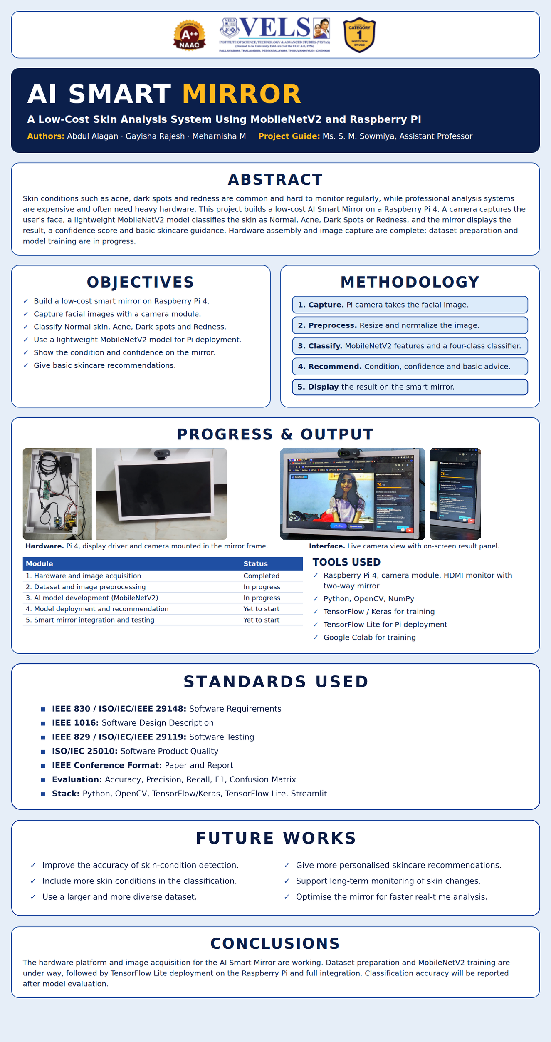

ABSTRACT
Regular monitoring of skin conditions such as acne, dark spots, and redness is difficult, and professional skin-analysis systems are expensive or need computing hardware that students and general users cannot easily access. This project develops a low-cost AI Smart Mirror that captures a user's facial image with a camera, classifies the skin into four categories (Normal Skin, Acne, Dark Spots, and Redness) with a lightweight MobileNetV2 deep-learning model, and shows the detected condition, a confidence score, and basic skincare guidance on a two-way mirror display. The system runs on a Raspberry Pi 4, and the trained model is to be converted to TensorFlow Lite for on-device inference. The work is organised into five modules: hardware and image acquisition, dataset and image preprocessing, AI model development, model deployment and recommendation, and smart mirror integration and testing. At the time of this report the first module is complete: the Raspberry Pi 4, camera module, display, and mirror frame have been assembled, and a prototype interface shows a live camera view with an on-screen result panel. Dataset preparation and MobileNetV2 training are in progress, and deployment and integration are yet to start. The report presents the problem, a survey of five recent studies, the system design, the implementation methodology, and the progress achieved, and it defines the evaluation protocol (accuracy, precision, recall, and F1) that will be applied once training is complete. No classification accuracy is claimed in this phase.
Keywords — skin analysis, smart mirror, MobileNetV2, Raspberry Pi, deep learning, TensorFlow Lite, computer vision

LIST OF FIGURES
Figure No. | Title
Figure 3.1 | System Architecture of the AI Smart Mirror
Figure 3.2 | Flow Chart of the Skin Analysis Process
Figure 4.1 | Gantt Chart of the Project Schedule
Figure 6.1 | Smart Mirror Hardware Prototype: (a) Internal Wiring in the Frame; (b) Front View with Camera
Figure 6.2 | Prototype Smart Mirror Interface with Live Camera View and Result Panel
Figure 6.3 | Smart Mirror Start-up Showing the Kali Linux Login Screen on the Raspberry Pi
Figure 6.4 | Mirror Interface Camera States: (a) Camera Closed; (b) Live Camera View
Figure 6.5 | Scan Output for Test Subject 1: (a) Result on the Mirror; (b) Close-up of the Result Panel
Figure 6.6 | Scan Output for Test Subject 2: (a) Result on the Mirror; (b) Close-up of the Result Panel
Figure 6.7 | Interface Output in a Web Browser with the Result Panel
Figure 11.1 | Conference Paper Submission Summary (Paper ID 758)

LIST OF TABLES
Table No. | Title
Table 1.1 | Project Objectives
Table 2.1 | Summary of the Literature Survey
Table 2.2 | Limitations Found in the Survey and the Response of the Proposed System
Table 3.1 | Major System Modules
Table 3.2 | Hardware Requirements
Table 3.3 | Software Requirements
Table 4.1 | Skin Condition Classes
Table 4.2 | Planned Recommendation Mapping
Table 5.1 | Module-wise Progress
Table 5.2 | Functional Testing Summary
Table 5.3 | Planned Evaluation Measures
Table 5.4 | Challenges Faced and Approach
Table 5.5 | Comparison of the Proposed System with Existing Approaches
Table 9.1 | Planned Dataset Record Fields
Table 9.2 | Project Schedule

LIST OF ABBREVIATIONS
Abbreviation | Full Form
AI | Artificial Intelligence
ML | Machine Learning
DL | Deep Learning
CNN | Convolutional Neural Network
CV | Computer Vision
API | Application Programming Interface
UI | User Interface
HDMI | High-Definition Multimedia Interface
OS | Operating System
SD | Secure Digital
IoT | Internet of Things
AR | Augmented Reality
RGB / BGR | Red-Green-Blue / Blue-Green-Red colour order
TFLite | TensorFlow Lite
OpenCV | Open Source Computer Vision Library
TP / FP / FN / TN | True Positive / False Positive / False Negative / True Negative
IEEE | Institute of Electrical and Electronics Engineers
CHAPTER 1

INTRODUCTION

1.1 General
Skin conditions such as acne, dark spots, and redness are among the most common concerns people notice in the mirror every day. They change slowly, they are affected by lighting, sleep, diet, and skincare habits, and most people have no simple way of tracking them from one week to the next. A visit to a dermatologist is the reliable option, but it is not something most students and general users do for a routine check.
Artificial Intelligence and Computer Vision have made it possible to analyse a photograph of the face and recognise visible skin conditions automatically. Recent studies combine deep learning with cameras, mobile applications, and smart mirrors to detect acne, assess skin health, and recommend skincare products [1]–[5]. A smart mirror is an attractive place for such a system, because looking in a mirror is already a daily habit and the user does not have to start a separate application.
This project builds a low-cost AI Smart Mirror for skin analysis. A camera attached to a Raspberry Pi 4 captures the user’s face, a lightweight MobileNetV2 deep-learning model [6] classifies the skin into one of four categories, and the result is displayed on a two-way mirror together with a confidence score and simple skincare guidance.

1.2 Problem Description
The problem addressed by this project is how to provide basic, regular skin-condition monitoring through a system that is cheap, simple to use, and able to run on small hardware. The system should recognise four categories (Normal Skin, Acne, Dark Spots, and Redness), report how confident it is, and present the result in a form that an ordinary user can understand without any technical background.
Several practical difficulties shape this problem. First, professional skin analysis systems are expensive and inaccessible for students and general users. Second, many AI-based skin analysis systems need high computational resources, cloud services, or complex hardware, which raises both cost and privacy concerns. Third, the accuracy of image-based skin analysis depends on lighting and camera quality, so a model trained on one kind of image may not work well on another. Fourth, a suitable and balanced dataset covering all four categories has to be collected and prepared. Finally, the trained model has to run on the limited processor and memory of a Raspberry Pi 4 and respond quickly enough for real-time use.

1.3 Existing System
Existing work on AI-based skin analysis follows several directions. Cloud-based Internet of Things systems use computer vision and deep learning to detect acne, assess its severity, and give personalised recommendations, and they allow remote monitoring [1]. Smart mirror applications combine face verification, acne detection, skin analysis, and event-based outfit recommendation [2], or use deep learning, computer vision, and augmented reality to analyse facial skin conditions and offer virtual enhancement [3]. Raspberry Pi based mirrors provide a low-cost platform that displays time, date, weather, news, and reminders [4]. Deep-learning systems have also been developed to recommend skincare products from facial skin conditions and cosmetic ingredient analysis [5].
These systems have recurring limitations. Several need a large dataset and high hardware or cloud capacity, which makes them costly and raises privacy concerns [1], [2], [3]. Their results depend on lighting and camera quality, they detect only visible skin conditions, and their recommendations may not always suit the user. The low-cost Raspberry Pi mirror in [4] has limited AI capability and no advanced skin analysis. No single system in the survey combines low cost, on-device analysis, and a focused set of common skin conditions.

1.4 Proposed System
The proposed system is a low-cost AI Smart Mirror that uses a camera to capture the user’s facial image and a MobileNetV2-based deep-learning model to classify the skin into four categories: Normal Skin, Acne, Dark Spots, and Redness. The Raspberry Pi processes the image and displays the detected condition, the confidence score, and a basic skincare recommendation on the smart mirror.
The system works in four steps. In facial image capture, a camera connected to the Raspberry Pi 4 captures the user’s face in real time. In AI-based skin classification, the image is preprocessed and analysed by a lightweight MobileNetV2 model. In result and recommendation generation, the system produces the detected condition together with a confidence score and a basic skincare recommendation. In smart mirror display, the prediction and the recommendation are shown on the mirror interface, which gives a simple and user-friendly experience.

1.5 Objectives
The objectives of this project are summarised in Table 1.1.
No. | Objective
1 | Develop a low-cost AI-based smart mirror using a Raspberry Pi 4.
2 | Capture facial images using a camera module.
3 | Classify basic skin conditions into four categories: Normal Skin, Acne, Dark Spots, and Redness.
4 | Use a lightweight MobileNetV2-based deep-learning model suitable for Raspberry Pi deployment.
5 | Display the detected condition and the confidence score on the mirror.
6 | Provide basic skincare recommendations based on the detected condition.
Table 1.1: Project Objectives

1.6 Scope of the Project
The project covers one hardware platform, the Raspberry Pi 4 with a camera module and an HDMI monitor behind a two-way mirror. The classification task is limited to four categories of visible facial skin condition, and the model is a MobileNetV2 network trained with TensorFlow/Keras and intended for deployment through TensorFlow Lite.
The project does not attempt to diagnose skin disease, to replace a dermatologist, or to detect conditions that are not visible in a photograph. It does not include a clinical study. The skincare recommendations are basic, general guidance linked to the detected category, and the confidence score is an indication of the model’s certainty and not a medical measurement. The optional database for storing images, results, and user history is outside the core scope of this phase.

1.7 Contributions
The main contributions of the project up to this phase are:
- A low-cost smart mirror hardware platform, assembled from a Raspberry Pi 4, a camera module, a display, and a mirror frame, with working facial image acquisition.
- A clearly defined four-class skin-condition scheme and a lightweight MobileNetV2 classification design suited to Raspberry Pi deployment.
- An end-to-end workflow that runs from image capture and preprocessing, through feature extraction and classification, to confidence scoring, recommendation, and on-mirror display.
- A prototype interface that shows a live camera view with an on-screen result and recommendation panel.
- A comparative survey of five recent studies on smart mirrors and AI-based skin analysis, with their advantages, disadvantages, and future scope.
- A staged project plan with module-wise progress tracking and a Gantt chart of milestones.

1.8 Modules
The system is organised into five modules. They are listed in Table 3.1 and implemented in Chapter 4.
- Hardware and image acquisition: Raspberry Pi 4 setup, camera connection, display setup, and capture of facial images.
- Dataset and image preprocessing: dataset collection, classification into four categories, and image resizing and normalization.
- AI model development: MobileNetV2-based model training for Normal Skin, Acne, Dark Spots, and Redness.
- Model deployment and recommendation: TensorFlow Lite conversion, Raspberry Pi deployment, prediction, and skincare recommendation.
- Smart mirror integration and testing: display of the prediction, confidence score, and recommendation, followed by complete system integration and testing.

1.9 Summary
This chapter explained why regular skin-condition monitoring is difficult, described how existing AI-based and smart-mirror systems depend on heavy hardware or have limited analysis, and introduced the proposed low-cost AI Smart Mirror. It also set out the objectives, scope, contributions, and modules of the project. The next chapter reviews the literature on which the project builds.
CHAPTER 2

LITERATURE REVIEW
This chapter reviews the work that this project builds on. It covers five recent studies on smart mirrors and AI-based skin analysis, and the background on lightweight neural networks and transfer learning that makes on-device analysis possible. The studies were chosen because each addresses a part of the problem in this project: detecting skin conditions from images, presenting results through a smart mirror, running on low-cost hardware, or turning an analysis into a recommendation.
Each study is described in terms of what it builds, what it offers, what limits it, and where its authors plan to go next. The studies are then compared with one another, the problems that recur across them are identified, and these are used to state the research gap and the design choices of this project. The review reports only what the studies themselves state; where this chapter draws a conclusion for the project, it says so.

2.1 AI-Based Acne Assessment
Khalid et al. [1] present an AI-enabled, cloud-based Internet of Things system for monitoring facial acne. It uses computer vision and deep learning to detect skin conditions, assesses acne severity automatically, and provides personalised recommendations. The study also allows remote monitoring. Its advantages are automatic severity detection, personalised recommendations, and remote monitoring. Its disadvantages are the need for a large dataset, high hardware or cloud requirements, and privacy concerns. The authors point to better accuracy, more detectable skin conditions, and remote dermatologist consultation as future work.
The significance of this study for the present project lies in its two ideas: severity is estimated automatically from the image, and the result is turned into advice for the user. Both ideas are carried into this project in a simpler form. Instead of grading severity on a scale, the proposed system names the visible condition and reports how confident the model is, and instead of a cloud-based back end it keeps the whole analysis on the device. The privacy concern and the hardware requirement that the study accepts as the cost of cloud processing are exactly the points this project tries to avoid.
The study also shows why a continuous record matters for acne, which changes over weeks and not over minutes. A single image gives a snapshot, whereas remote monitoring builds a history. This project does not store user history in its core scope, but the optional database block in the architecture leaves room for it, so the idea of tracking a condition over time remains open for later work.

2.2 Smart Mirror with Fashion Recommendation
Rathnasekara et al. [2] describe an AI smart mirror that performs face verification, acne detection, and skin analysis and recommends outfits for social events. The system offers combined skin and fashion analysis, real-time AI processing, and useful updates. It requires high processing power, its recommendations may not always match the user, and it depends on lighting and camera quality. Planned extensions include a voice assistant, body-type analysis, and wardrobe management.
This study is the closest in form to the present project, because it also places a camera and an analysis engine behind a mirror. Its fashion recommendation shows how a mirror can offer more than a reflection, but it also shows how quickly the demand on the hardware grows when several analyses run together: face verification, acne detection, skin analysis, and outfit selection each add to the processing needed in real time.
The study reports that the recommendations may not always match the user and that results depend on lighting and camera quality. These two points are relevant here for different reasons. The first is a reminder that any recommendation should be general and modest, which is why this project limits its guidance to broad advice and a reminder to consult a dermatologist. The second supports the choice of a fixed camera position above the mirror, which gives a more consistent view of the face than a handheld device.

2.3 Deep Learning for Health Evaluation and Virtual Enhancement
Uchhoi, Chahar, and Yadav [3] use deep learning, computer vision, and augmented reality in a smart mirror that analyses facial skin conditions. The system supports AI-based skin and health evaluation, personalised skincare recommendations, and virtual makeup through augmented reality. It is affected by poor lighting and camera quality, detects only visible skin conditions, and needs advanced AI hardware. Future work includes better disease detection, wearable integration, and cloud-based health monitoring.
This study is useful because it places skin analysis inside the smart mirror itself, so the analysis happens in a place where the user already looks at their face every day. The combination of skin analysis with a second function, outfit recommendation, makes the mirror more attractive to a user but also makes the system larger. The study's own list of disadvantages, the processing power and the dependence on lighting and camera quality, follows directly from trying to do more than one task on one device.
For the present project, the lesson is to keep the scope narrow. Restricting the mirror to four skin categories and a short piece of guidance is a deliberate choice that keeps the model small enough for a Raspberry Pi. The reported dependence on lighting also confirms that images should be collected under varied lighting, which is part of the dataset plan in Chapter 4.

2.4 Raspberry Pi Based Smart Mirror
Kiran, Ravi, and Umadevi [4] build a Raspberry Pi based smart mirror that displays real-time information such as time, date, weather, news, and reminders. The system is low-cost, energy-efficient, and user-friendly. Its AI capability is limited, it has no advanced skin or health analysis, and it offers few smart features. The authors suggest integrating AI, facial recognition, health monitoring, and cloud connectivity. This work shows that a Raspberry Pi is a practical and affordable base for a smart mirror, which supports the hardware choice in this project.
The strength of this study is the hardware. It treats the mirror as an ordinary display with a mirror surface in front of it, and shows that such a mirror can be built cheaply and run continuously without much power. Its weakness for the present purpose is that the mirror only presents information from other sources and does not analyse the person standing in front of it.
This project takes the same hardware approach and adds the missing part, a camera and a model. The authors of [4] suggest integrating AI and facial recognition as future work, and this project can be seen as a step in that direction for one specific purpose, skin analysis, without the cloud connectivity that [4] also lists.

2.5 Skincare Product Recommendation
Lee et al. [5] develop a deep-learning system that analyses facial skin conditions together with cosmetic ingredients to recommend personalised skincare products. It gives high accuracy by considering both the skin condition and the ingredients. It needs a large, high-quality dataset, depends on image quality and lighting, and is limited to the products in its database. Planned work includes integration with smart mirrors and mobile applications, detection of more skin conditions, and dermatologist consultation.
The study shows that a recommendation is more useful when it rests on more than one kind of information. By considering both the skin condition and the ingredients of the products, it can recommend products that suit the detected condition and avoid those that do not. The cost is the need for a large, high-quality dataset that links conditions with ingredients, and a recommendation list that cannot go beyond the products in its database.
The recommendation module of this project is deliberately simpler. It maps each of the four conditions to a short piece of general guidance and does not recommend commercial products. This avoids the dependence on a product database and avoids the risk of advice that does not suit the user, which [2] also lists as a limitation. The integration with smart mirrors that the authors of [5] list as future work is the direction in which the present system already points.

2.6 Lightweight Networks and Transfer Learning
MobileNetV2 [6] is a convolutional neural network designed for devices with limited computing power. It is built from depthwise separable convolutions and inverted residual blocks with linear bottlenecks, which keep the number of parameters and computations small while preserving accuracy. Because it is small, it is a natural choice for a Raspberry Pi, where a larger network would respond too slowly.
Transfer learning reuses a network that has already been trained on a large image collection such as ImageNet [7] and adapts it to a new task using a much smaller dataset. This suits the present project, where only a limited number of skin images are available for each category. The TensorFlow library [8] provides the tools for training the network and converting it to the compact TensorFlow Lite format for on-device use, and OpenCV [9] and NumPy [10] handle image capture, resizing, and array processing.
The saving in computation comes from replacing a standard convolution with two cheaper steps. A depthwise convolution filters each input channel on its own, and a pointwise convolution with a 1 × 1 kernel then combines the channels. For the 3 × 3 kernels used in MobileNetV2 this reduces the number of multiplications to roughly one eighth or one ninth of a standard convolution [6]. MobileNetV2 has about 3.4 million parameters and needs about 300 million multiply-add operations for one 224 × 224 image [6], which is small enough for a Raspberry Pi 4 to process one image in a short time.
The inverted residual block expands the number of channels, filters them with the depthwise convolution, and then compresses them again with a linear projection. The shortcut connection joins the narrow layers, which keeps information flowing through the network while the wide layers do the filtering. Leaving out the non-linearity after the final projection, the linear bottleneck, avoids destroying information in the narrow layer [6]. These choices are why the network keeps good accuracy at a small size.
Transfer learning has a practical consequence for the training procedure. In the first stage the pretrained layers are kept fixed and only the new classification layers are trained, so the network learns to map the general image features it already has onto the four skin categories. In the second stage the upper layers are unfrozen and adjusted at a low learning rate, so that the features become more specific to skin images without losing what was learned from ImageNet. The Adam optimiser [11] is used for both stages because it adapts the step size for each weight and works well with little tuning.
Finally, conversion to TensorFlow Lite prepares the trained network for the Raspberry Pi. The converter can store the weights in a reduced numerical precision, which makes the file smaller and the inference faster, usually at a small cost in accuracy. For this reason the evaluation plan in Chapter 4 measures the converted model again on the test set and does not assume that it performs as well as the original.

2.7 Existing Systems and Limitations
Table 2.1 summarises the five surveyed studies. Taken together, they show that AI-based skin analysis is effective but is often tied to large datasets, cloud services, or powerful hardware. Results are sensitive to lighting and camera quality, only visible conditions can be detected, and privacy is a concern when images are sent to a server. Simple Raspberry Pi mirrors avoid the hardware cost but offer little or no skin analysis.
Ref. | Focus of the study | Advantages | Disadvantages
[1] | AI and cloud-based IoT acne severity monitoring | Automatic severity detection; personalised recommendations; remote monitoring | Large dataset; high hardware or cloud requirement; privacy concerns
[2] | Smart mirror for skin analysis and fashion recommendation | Skin and fashion analysis; real-time AI processing; useful updates | High processing requirement; recommendations may not match; depends on lighting and camera
[3] | Smart mirror with deep learning, vision, and AR | AI skin and health evaluation; personalised skincare; virtual makeup | Affected by poor lighting; visible conditions only; needs advanced AI hardware
[4] | Raspberry Pi smart mirror for information display | Low-cost; energy-efficient; user-friendly | Limited AI capability; no advanced skin or health analysis; fewer smart features
[5] | Skincare product recommendation from skin condition and ingredients | Personalised recommendations; high accuracy | Large, high-quality dataset; depends on image quality; limited to database products
Table 2.1: Summary of the Literature Survey
Reading the table by column, the advantages are mostly about what the systems can do: they detect, assess, recommend, display, or monitor. The disadvantages are mostly about what the systems need: data, processing power, a network, or good lighting. This pattern is the main finding of the survey. The studies that do the most analysis ask the most of the user's hardware and data, and the one study that asks the least [4] does the least analysis.
None of the five studies reports a system that does skin analysis entirely on a low-cost board. The studies that use deep learning [1], [2], [3], [5] rely on large datasets, cloud services, or powerful hardware to some degree, and the Raspberry Pi mirror [4] has no skin analysis. The comparison therefore places this project in a region the survey leaves open: a small neural network, running locally, on inexpensive hardware, for a small number of common conditions.

2.8 Comparative Analysis of the Surveyed Studies
The five studies can be compared along four dimensions: where the analysis runs, how much it needs, what it detects, and what it gives back to the user.
Where the analysis runs. The study in [1] relies on cloud-based Internet of Things infrastructure, so the image leaves the user's location. The smart mirrors in [2] and [3] are described as needing high processing power or advanced AI hardware, which usually means a powerful local computer or a server. The Raspberry Pi mirror in [4] runs locally but performs no skin analysis. A system that analyses locally on a small board is therefore not represented among the five.
What it needs. Dataset size and image quality are limiting factors in [1] and [5], and lighting and camera quality in [2], [3], and [5]. These requirements are not flaws in the studies. They are properties of image-based skin analysis in general, and any new system has to plan for them. For the present project the plan is to include varied lighting in the dataset, to use a fixed camera, and to keep the four categories balanced.
What it detects. The studies detect different things: acne and its severity [1], acne and general skin condition [2], skin and health condition [3], and skin condition together with product ingredients [5]. Acne appears in the first two. Choosing acne, dark spots, and redness together with a normal class gives a task that is narrow enough for a small model and still covers concerns people commonly notice.
What it gives back. The studies return a severity rating [1], an outfit suggestion [2], virtual makeup and skincare advice [3], information such as time and weather [4], or a product list [5]. The proposed system returns the detected condition, a confidence score, and a short piece of guidance. The confidence score is worth noting because it tells the user how much weight to give the result.

2.9 Common Challenges in Image-Based Skin Analysis
Several challenges appear in more than one of the studies and are described here, because the design of this project responds to each of them.
Lighting and camera quality. The apparent colour and texture of skin change with the light source, its direction, and the camera. Redness and dark spots depend on colour, so they are especially sensitive to this. A model trained on images from one setting can perform worse in another. The usual remedies are to collect data under several lighting conditions, to apply brightness and similar augmentation during training, and to fix the camera position, all of which are part of this project.
Dataset size and balance. Deep networks usually need many labelled images, and labelled images of skin conditions are harder to collect than general photographs. If one category has many more images than the others, a model can reach a high accuracy simply by favouring the common class. For this reason the evaluation plan reports precision, recall, and F1 for each class and compares accuracy with a majority-class baseline, instead of relying on overall accuracy alone.
Separation of people between data sets. If images of the same person appear in both the training and the test set, the model can recognise the face and not the skin condition, and the test result is too optimistic. The data plan therefore keeps all images of one person in one set only.
Visible conditions only. An image shows only the surface of the skin. Conditions that cannot be seen, and the cause of a condition that can, are outside what a camera-based system can say. This is why the system is described as a monitoring and guidance aid and not as a diagnostic tool, and why the mirror reminds the user to consult a dermatologist for persistent or severe conditions.
Privacy. A face image is personal data. Sending it to a server, as cloud-based systems do, creates a copy outside the user's control and requires a network connection. Processing the image on the device and not storing it by default keeps the data with the user.

2.10 Design Implications for This Project
The survey leads to a set of design decisions that are summarised in Table 2.2. Each row gives a limitation seen in the studies, the studies in which it appears, and the response taken in this project.
Limitation seen in the survey | Studies | Response in this project
Large dataset or cloud service needed | [1], [5] | Pretrained MobileNetV2 with transfer learning; the model is stored and run on the Raspberry Pi
High processing or hardware requirement | [1], [2], [3] | Lightweight network, TensorFlow Lite conversion, and a limited scope of four categories
Privacy concern when images are sent out | [1] | On-device analysis; no cloud server is needed for classification
Dependence on lighting and camera quality | [2], [3], [5] | Fixed camera position, varied lighting in the dataset, and brightness augmentation
Only visible conditions detected | [3] | Scope limited to visible conditions; no diagnosis; dermatologist reminder shown
Limited AI capability in low-cost mirrors | [4] | Camera and classification model added to a Raspberry Pi mirror
Recommendations that may not suit the user | [2], [5] | General guidance mapped to the detected condition, with no product recommendations
Table 2.2: Limitations Found in the Survey and the Response of the Proposed System
These decisions share one idea, which is to do less in order to run on less. The system does not try to diagnose, to recommend products, or to run several analyses together. It classifies four visible categories with a small network, and it reports the result with a confidence value and a short piece of advice. The next chapters show how this idea is turned into a design, an implementation, and an evaluation plan.

2.11 Research Gap
Based on this review, the gap addressed by this project is the combination of four elements that the surveyed systems do not offer together: a low-cost platform built on a Raspberry Pi 4, a lightweight MobileNetV2 model that is small enough to run on that platform without a cloud server, a focused set of four common skin conditions (Normal Skin, Acne, Dark Spots, and Redness), and a simple on-mirror display of the condition, the confidence score, and a basic recommendation.

2.12 Summary
This chapter reviewed five recent studies on smart mirrors and AI-based skin analysis and the background on lightweight networks and transfer learning, compared the studies, listed the challenges common to them, and drew the design implications for this project. Existing systems are either computationally heavy or limited in analysis, and the research gap is a low-cost, on-device, focused skin analysis mirror. The next chapter presents the system design.
CHAPTER 3

SYSTEM DESIGN

3.1 Existing System
In existing workflows, a person who wants to check their skin either visits a professional or uses an application or mirror that sends images to a cloud service or needs powerful local hardware. Professional systems are expensive, cloud systems raise privacy concerns and need a network connection, and simple smart mirrors show information but do not analyse the skin. None of these gives a user a quick, private, low-cost check at the place where they already look at their face every day.

3.2 Proposed System
The proposed system places the analysis inside the mirror itself. It is organised as an offline stage, in which the dataset is prepared and the MobileNetV2 model is trained on Google Colab, and an online stage, in which the converted model runs on the Raspberry Pi and analyses each captured image. The trained model is stored on the microSD card of the Raspberry Pi, so no cloud server is needed for the classification itself.
The user interface, backend processing, deep-learning feature extraction, and classifier are kept as separate blocks. This makes it possible to improve one block, for example to retrain the model on a larger dataset, without changing the others.

3.3 System Architecture
Figure 3.1 shows the overall architecture of the system. The user interface block captures the image through the camera and can be extended to a web or mobile application. The image is passed to the backend server block, which exposes API endpoints and performs preprocessing. The processed image goes to the deep-learning block, where MobileNetV2 produces a feature vector. The classifier block uses these features to assign one of the four skin conditions. Result generation then prepares the confidence score and the on-screen output. An optional database block can store images, results, and user history, so that earlier results can be fetched later.
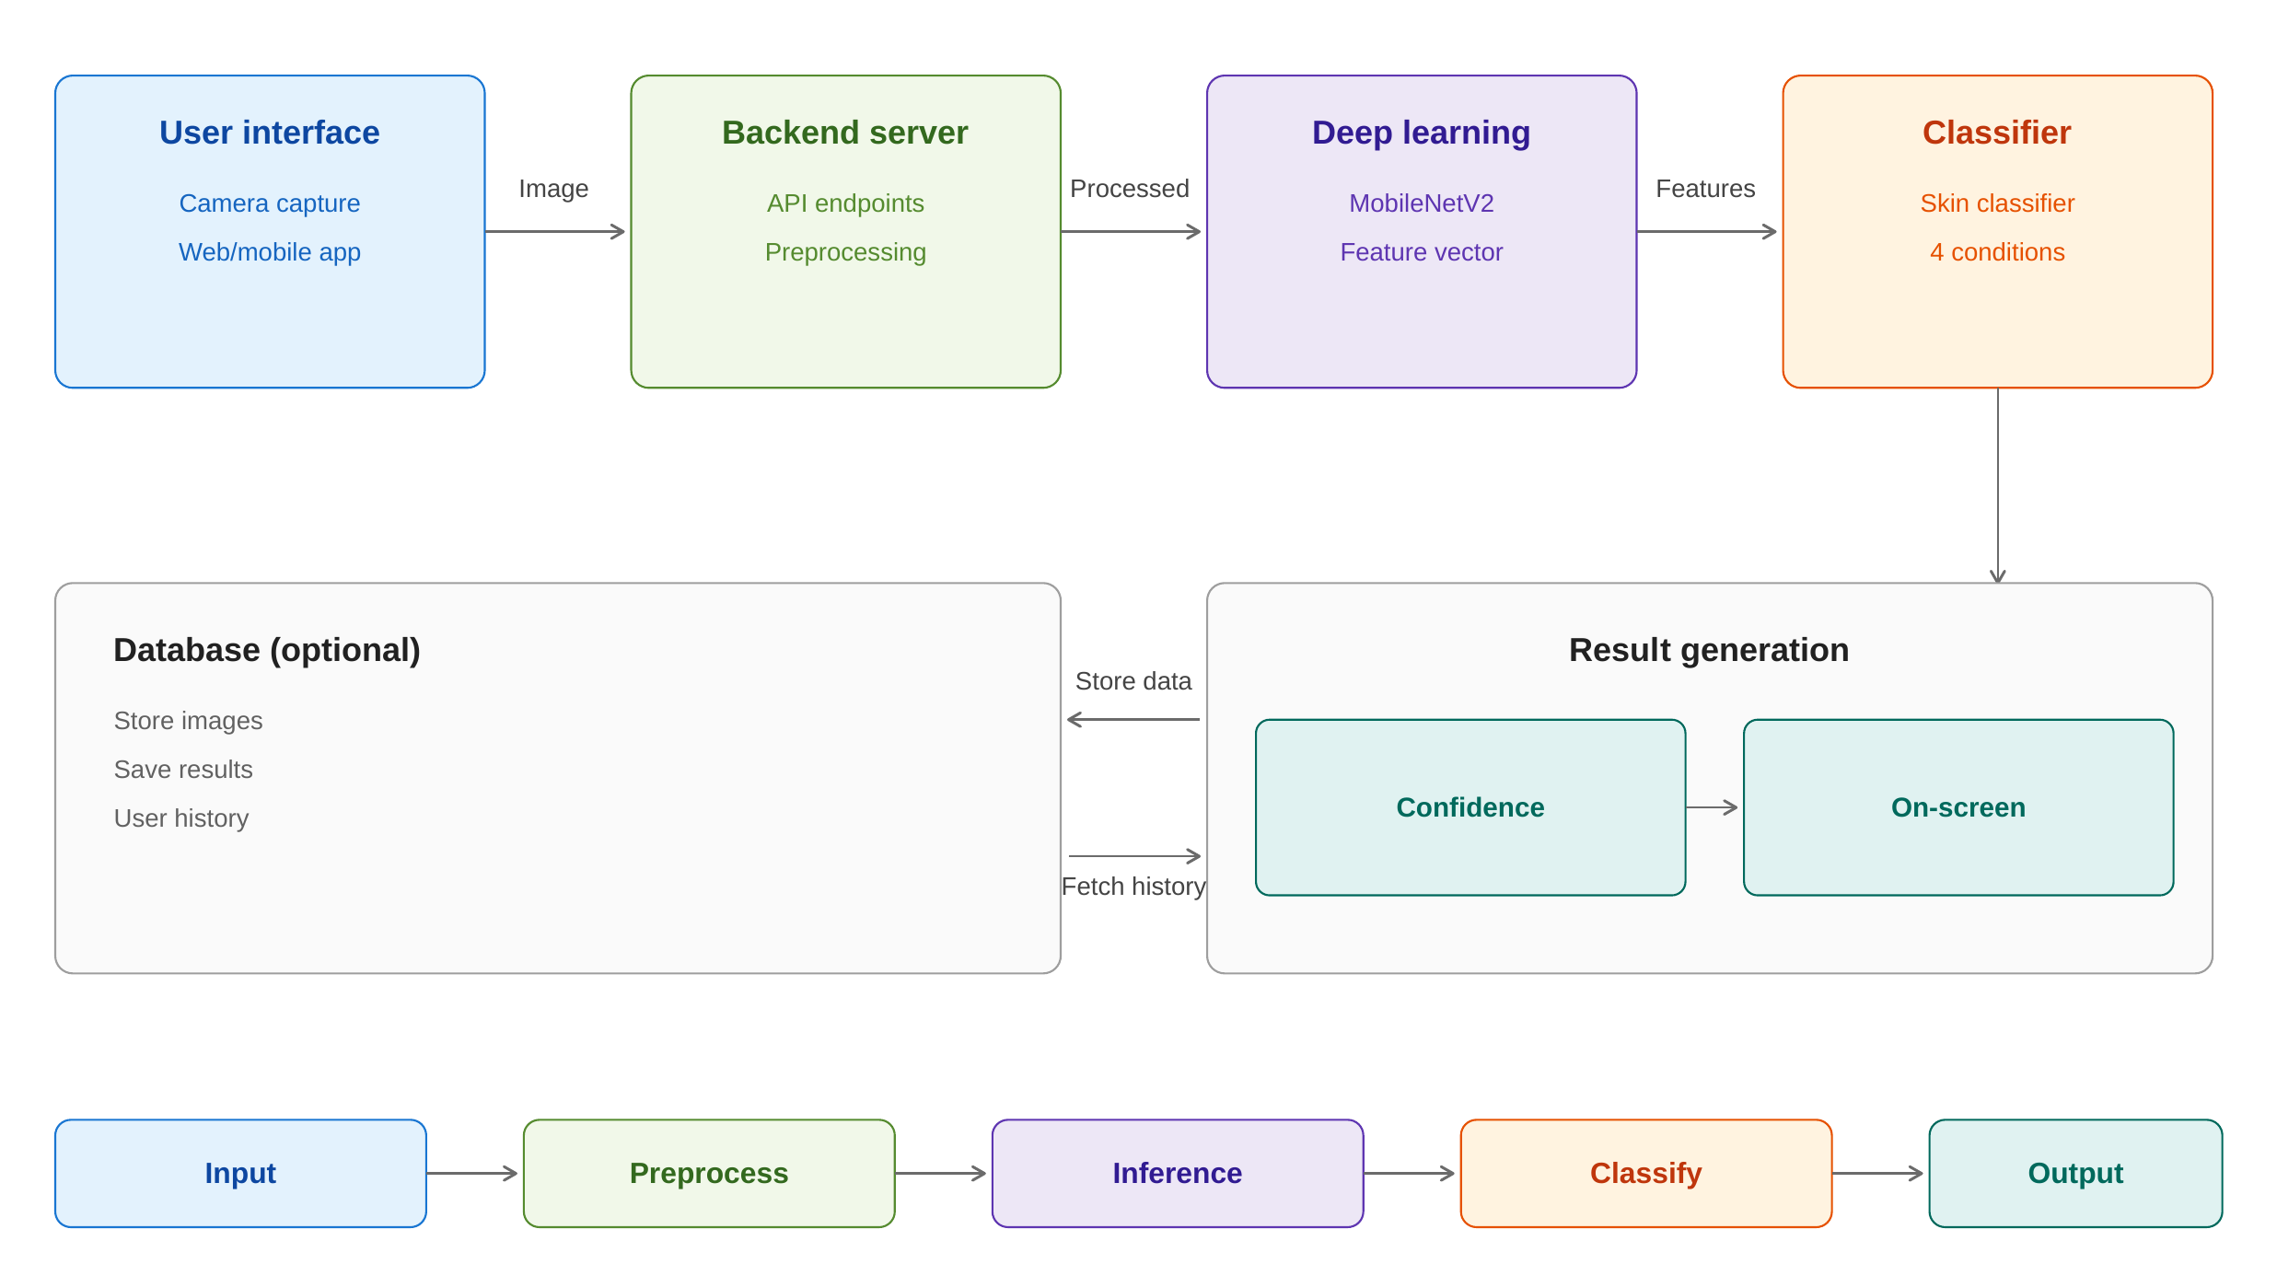
Figure 3.1: System Architecture of the AI Smart Mirror
The bottom row of the figure summarises the main path as five stages: input, preprocess, inference, classify, and output. Each stage hands its result to the next, which keeps the design easy to test one stage at a time.

3.4 Overall Workflow
The workflow of the smart mirror proceeds in the following order:
- Image capture: the camera connected to the Raspberry Pi captures a facial image.
- Image preprocessing: the image is resized and normalized.
- Feature extraction: MobileNetV2 extracts features from the preprocessed image.
- Skin classification: the features are analysed and the skin is classified into Normal Skin, Acne, Dark Spots, or Redness.
- Result generation: the predicted condition is produced together with a confidence score.
- Recommendation: a basic skincare recommendation is selected for the detected condition.
- Display: the result and the recommendation are shown on the smart mirror.

3.5 System Modules
Table 3.1 lists the five modules of the project and the main activities of each.
Module | Main activities
Module 1: Hardware and image acquisition | Raspberry Pi 4 setup, camera connection, display setup, and capturing facial images.
Module 2: Dataset and image preprocessing | Dataset collection, classification into four categories, image resizing, and normalization.
Module 3: AI model development | MobileNetV2-based model training for Normal Skin, Acne, Dark Spots, and Redness.
Module 4: Model deployment and recommendation | TensorFlow Lite conversion, Raspberry Pi deployment, prediction, and skincare recommendation.
Module 5: Smart mirror integration and testing | Display of prediction, confidence score, and recommendation; complete system integration and testing.
Table 3.1: Major System Modules

3.6 Data Flow
Figure 3.2 shows how data moves through the system. A facial image enters from the camera and is resized and normalized. The preprocessed image is passed to MobileNetV2 for feature extraction and then to the four-class classifier. The classifier’s output, a predicted category and its probability, becomes the confidence score. The recommendation step looks up the guidance linked to the predicted category, and the final result is shown on the mirror display.
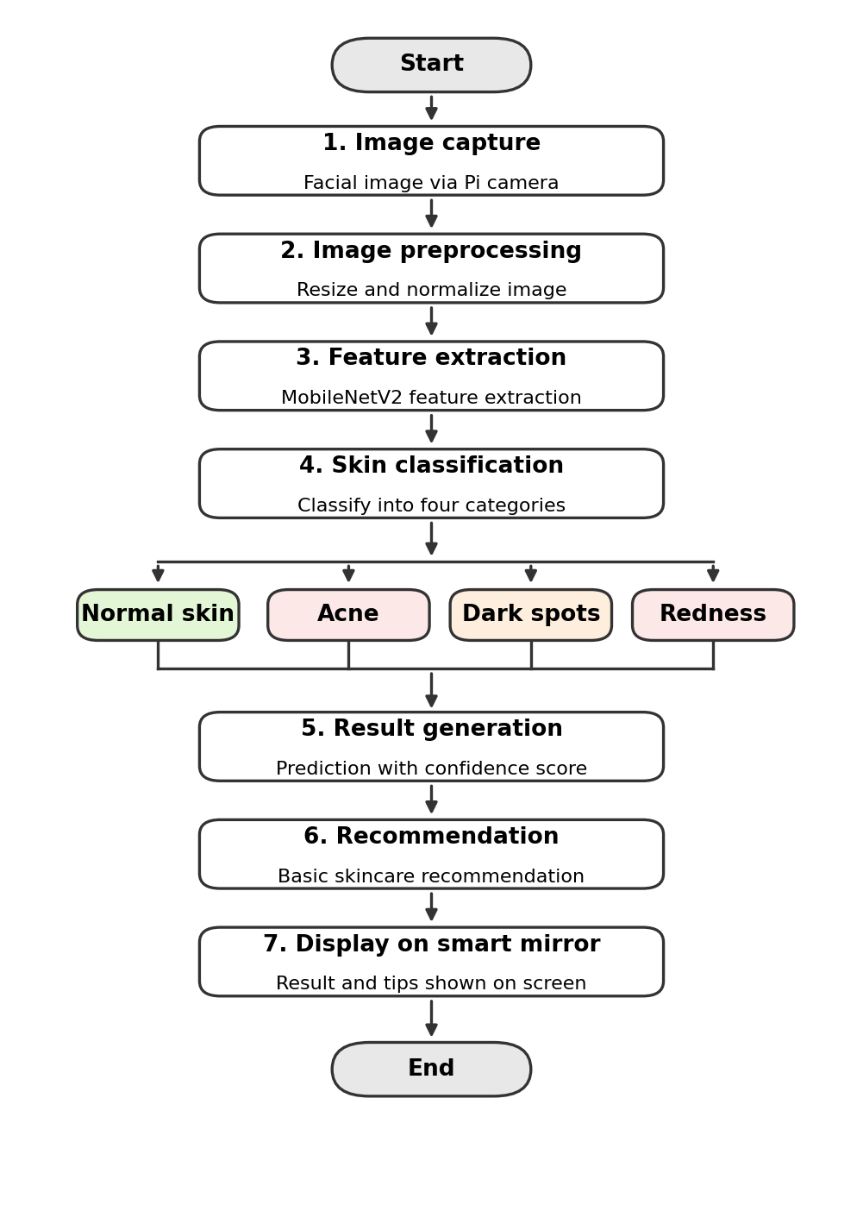
Figure 3.2: Flow Chart of the Skin Analysis Process
The trained model file and the recommendation text are the only items the online stage needs besides the camera image. This keeps the running system small and quick to start on the Raspberry Pi.

3.7 Hardware Requirements
Table 3.2 lists the hardware used in the project.
Component | Specification / Purpose
Raspberry Pi 4 | Main processing unit.
Camera module | Captures facial images.
HDMI monitor and two-way mirror | Displays the detection results through the mirror surface.
MicroSD card | Stores the operating system and the AI model.
Power supply and cables | Powers and connects the system.
Table 3.2: Hardware Requirements
The limited processor and memory of the Raspberry Pi 4 shaped several design decisions. A lightweight network was chosen, the model is trained on a separate computer, and it is converted to TensorFlow Lite before deployment.

3.8 Software Requirements
Table 3.3 lists the main software components.
Component | Purpose
Kali Linux | Operating system for the Raspberry Pi.
Python | Programming language for all components.
OpenCV [9] | Image capture and processing.
TensorFlow / Keras [8] | AI model development.
TensorFlow Lite | Model deployment on the Raspberry Pi.
NumPy [10] | Numerical data processing.
Google Colab | Model training.
Table 3.3: Software Requirements

3.9 Summary
This chapter described the existing and proposed systems, the architecture, workflow, modules, and data flow of the AI Smart Mirror, and the hardware and software it needs. The design keeps image capture, preprocessing, classification, and display as separate stages. The next chapter explains how each stage is implemented.
CHAPTER 4

IMPLEMENTATION AND METHODOLOGY
This chapter describes how each stage of the system is implemented. Hardware assembly and image acquisition are complete. The dataset, preprocessing, and model stages are in progress, and the deployment stage has not yet started, so those parts are described as the adopted design and method and not as finished results.

4.1 Hardware Setup and Image Acquisition
The Raspberry Pi 4 is mounted inside a mirror frame together with the display driver board and the power supply. An HDMI monitor sits behind a two-way mirror, so that the screen output is visible through the mirror surface while the user still sees their own reflection. A camera module is placed above the display and connected to the Raspberry Pi to capture the user’s face. The assembled hardware is shown in Figure 6.1.
Images are read from the camera with OpenCV [9]. Each captured frame is passed to the preprocessing stage described in Section 4.3.

4.2 Dataset Collection and Class Definition
The classifier recognises four categories, defined in Table 4.1. Facial images are collected and sorted into one folder per category. Because the surveyed studies repeatedly report that results depend on lighting and camera quality, the dataset is planned to include images taken under different lighting conditions, and it will be kept as balanced as possible across the four categories.
Label | Class | Description
0 | Normal Skin | Skin with no visible acne, dark spots, or redness.
1 | Acne | Visible pimples or acne lesions on the face.
2 | Dark Spots | Visible areas of darker pigmentation on the skin.
3 | Redness | Visible reddish areas or irritation on the skin.
Table 4.1: Skin Condition Classes
The data will be divided into training, validation, and test sets, with every category represented in each set. Images of the same person will be kept in one set only, so that the model is not tested on faces it has already seen during training.

4.3 Image Preprocessing
Every image, whether from the dataset or from the live camera, is converted from the camera’s BGR colour order to RGB, resized to 224 × 224 pixels, which is the input size of MobileNetV2 [6], and normalized. The standard MobileNetV2 normalization maps each pixel value x in the range 0 to 255 to the range −1 to 1:
x′ = x / 127.5 − 1 (1)
During training, simple augmentation such as horizontal flips, small rotations, and brightness changes is applied to the training images. This increases the variety of the data and helps the model cope with different lighting. The same resize and normalization steps are applied at inference time, so that the model sees images in exactly the form it was trained on.

4.4 MobileNetV2 Classification Model
The classifier uses MobileNetV2 [6] with weights pretrained on ImageNet [7] as a feature extractor. The original 1,000-class output layer is removed. Global average pooling reduces the final feature maps to a single feature vector, a dropout layer reduces overfitting, and a dense layer with four outputs produces the class scores z₁, …, z₄. A softmax function converts these scores into probabilities that sum to one:
p(c) = exp(zc) / Σ exp(zk), k = 1, …, 4 (2)
The class with the highest probability is the predicted skin condition, and its probability is shown to the user as the confidence score.

4.5 Training Strategy
The model is trained on Google Colab using TensorFlow/Keras [8]. Training follows two stages. In the first stage, the pretrained MobileNetV2 layers are frozen and only the new classification layers are trained. In the second stage, some of the upper MobileNetV2 layers are unfrozen and fine-tuned at a lower learning rate. The Adam optimiser [11] is used, and the loss is the categorical cross-entropy between the true label y and the predicted probabilities:
L = − Σ yc · log p(c), c = 1, …, 4 (3)
The final values of the learning rate, batch size, and number of epochs will be chosen from the validation results, and the model with the best validation performance will be kept.

4.6 Evaluation Metrics
The trained model will be evaluated on the test set, which is not used in training or in model selection. For each class, with TP, FP, and FN denoting true positives, false positives, and false negatives, the metrics are:
Precision = TP / (TP + FP), Recall = TP / (TP + FN)
F1 = 2 · Precision · Recall / (Precision + Recall) (4)
Overall accuracy is the fraction of test images classified correctly, and a confusion matrix will show which categories are confused with each other. Since the categories may not be perfectly balanced, accuracy is compared with a majority-class baseline, the accuracy obtained by always predicting the most common class, where N_c is the number of test images of class c and N is the total:
Baseline = max(N_c) / N (5)

4.7 TensorFlow Lite Conversion and Deployment
After training, the model is converted to TensorFlow Lite so that it can run efficiently on the Raspberry Pi 4. The converter can also reduce the model size by quantization. The converted model file is copied to the microSD card, and a Python program on the Raspberry Pi loads it, preprocesses each captured frame, runs the model, and returns the predicted class and its probability. This stage has not yet been started.

4.8 Recommendation Module
The recommendation module maps the predicted category to a short piece of general skincare guidance, as outlined in Table 4.2. The guidance is basic and does not replace professional advice, and the mirror displays a reminder to consult a dermatologist for persistent or severe conditions.
Detected condition | Type of guidance shown
Normal Skin | Maintain the current routine, keep the skin hydrated, and use sun protection.
Acne | Use gentle cleansing, avoid touching or picking the skin, and consult a dermatologist if it is severe or persistent.
Dark Spots | Use sun protection and avoid prolonged sun exposure; consult a dermatologist for persistent pigmentation.
Redness | Avoid harsh products and known irritants, and consult a dermatologist if the redness persists.
Table 4.2: Planned Recommendation Mapping

4.9 Project Schedule
The project is planned in stages, from problem identification in July to the final report and journal paper submission in October. Figure 4.1 shows the Gantt chart with the review dates, and Table 9.2 in the Appendix lists the start and end dates of each activity.
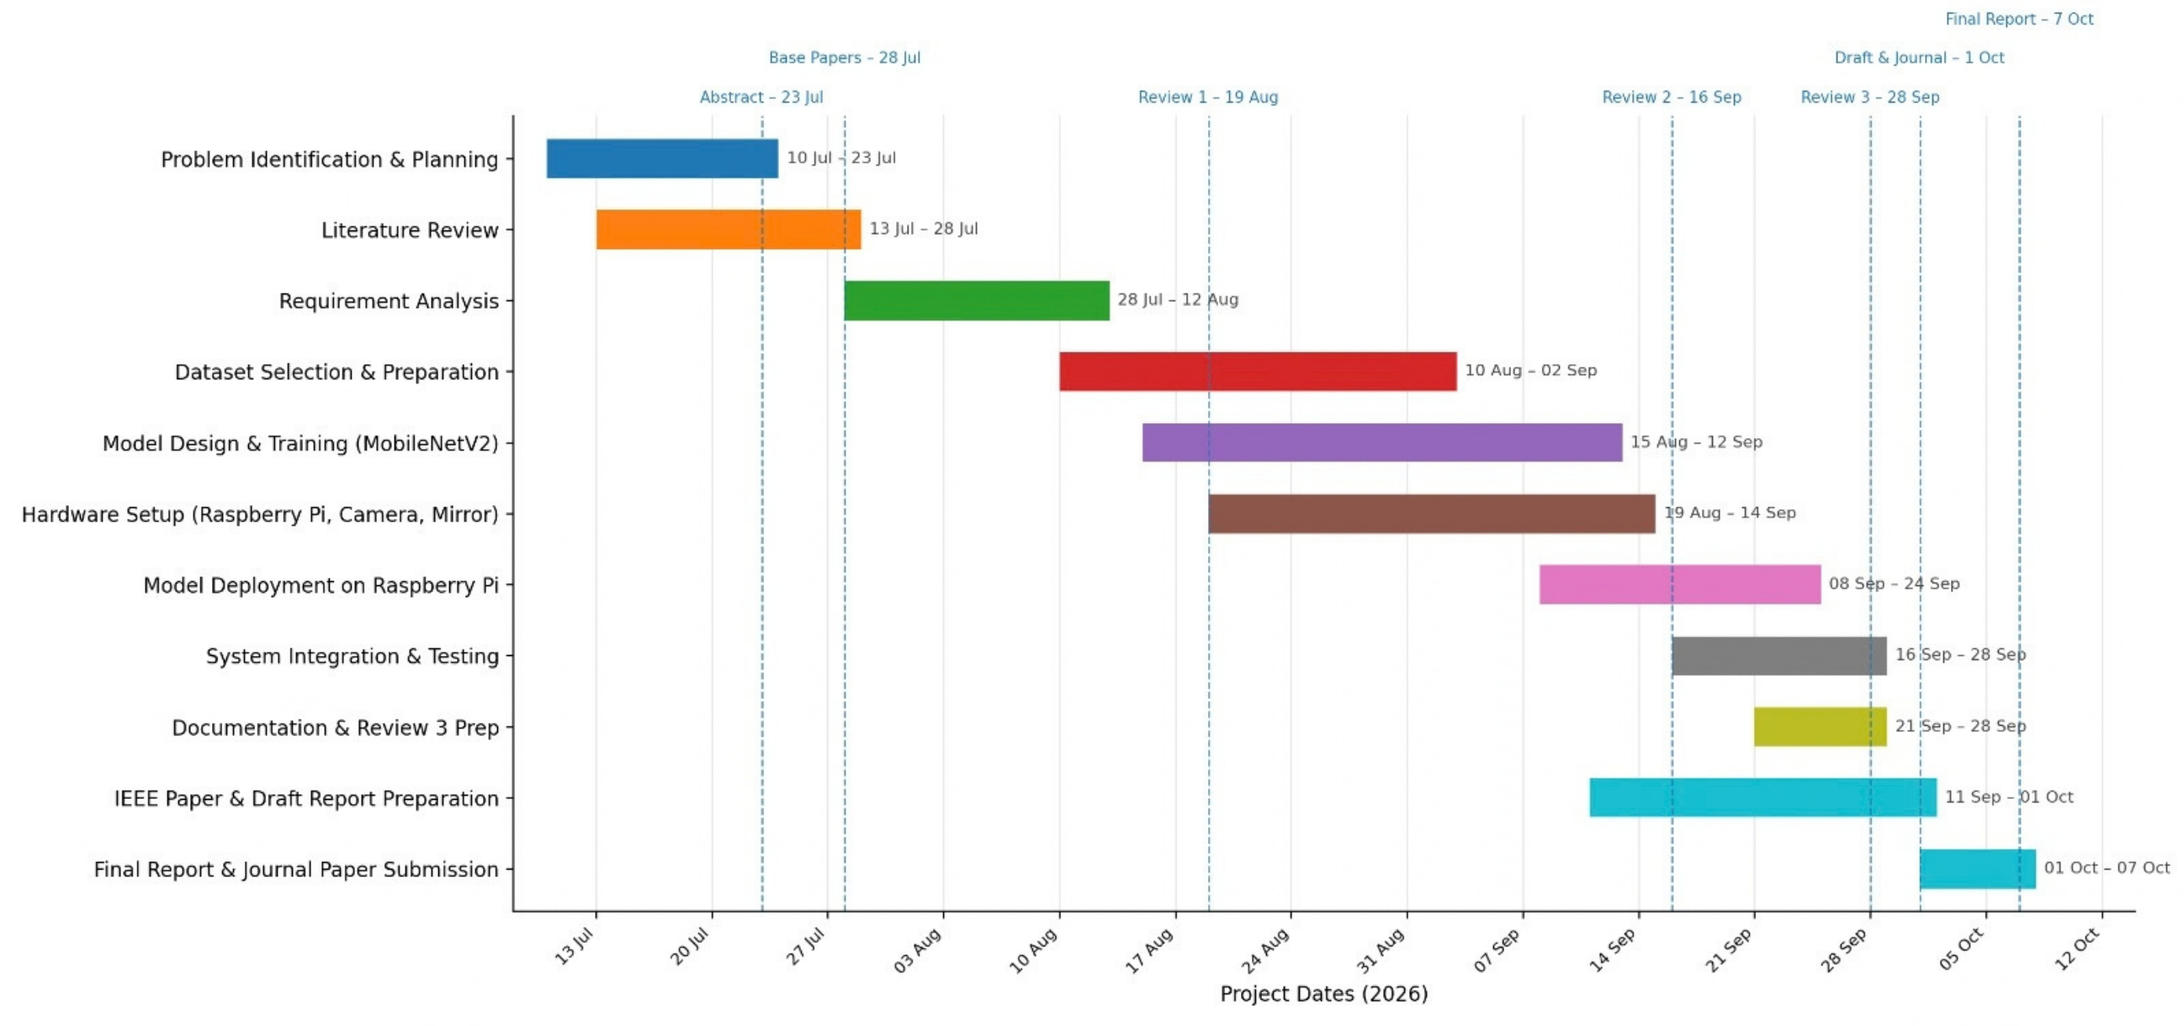
Figure 4.1: Gantt Chart of the Project Schedule

4.10 Summary
This chapter described the hardware setup, the four-class dataset, the preprocessing, the MobileNetV2 model and its two-stage training, the evaluation metrics, the TensorFlow Lite deployment, and the recommendation module, together with the project schedule. The next chapter reports the progress achieved and the evaluation planned for the remaining work.
CHAPTER 5

RESULTS AND DISCUSSION

5.1 Experimental Setup
The hardware used so far is the Raspberry Pi 4 with a camera module, an HDMI monitor, a two-way mirror, a microSD card, and a power supply. Model training is carried out on Google Colab with Python, TensorFlow/Keras, OpenCV, and NumPy. At the time of this report the experiments are at the hardware and data-preparation stage, so this chapter reports the progress made and the results of the functional checks. Classification accuracy, precision, recall, and F1 are not reported yet, because model training and evaluation are not complete.

5.2 Hardware Assembly Results
The Raspberry Pi 4 and the camera module have been set up successfully for facial image acquisition. The display has been installed behind the mirror frame, and the Raspberry Pi, display driver board, and power supply are mounted inside it. Figure 6.1 in the next chapter shows the interior of the frame and the front of the mirror with the camera above the screen.

5.3 Module-wise Progress
Table 5.1 summarises the progress of the five modules.
Module | Main activities | Status
1. Hardware and image acquisition | Pi 4 setup, camera connection, display setup, image capture | Completed
2. Dataset and image preprocessing | Dataset collection, four-class labelling, resizing, normalization | In progress
3. AI model development | MobileNetV2 training for four classes | In progress
4. Model deployment and recommendation | TensorFlow Lite conversion, Pi deployment, recommendation | Yet to start
5. Smart mirror integration and testing | Display of result, integration, complete testing | Yet to start
Table 5.1: Module-wise Progress
Dataset preparation and image preprocessing are in progress to prepare suitable inputs for model training. MobileNetV2 model development and training are also in progress, with model evaluation planned after training.

5.4 Functional Testing
Table 5.2 summarises the functional checks completed so far and those that remain.
Test area | Check performed | Result
Camera acquisition | Camera module connected to the Raspberry Pi 4 and used to capture facial images | Passed
Display and mirror | Monitor mounted behind the two-way mirror inside the frame | Completed
Prototype interface | Live camera view with scan button and on-screen result panel (Figure 6.2) | Demonstrated
Classification accuracy | Evaluation on the held-out test set | Pending
TensorFlow Lite deployment | Model running on the Raspberry Pi 4 | Not started
End-to-end operation | Capture, classification, and display on the mirror | Not started
Table 5.2: Functional Testing Summary

5.5 Planned Evaluation
When model training is complete, the model will be evaluated on the held-out test set with the metrics in Table 5.3. The same metrics will be computed again for the converted TensorFlow Lite model on the Raspberry Pi, to check that conversion has not reduced accuracy, and the response time per image will be measured on the device.
Measure | What it shows
Overall accuracy | Fraction of test images classified correctly, compared with the majority-class baseline.
Precision, recall, and F1 per class | How reliably each of the four conditions is detected, and how many are missed.
Confusion matrix | Which conditions are mistaken for each other.
Performance under different lighting | Whether accuracy drops with poor or uneven lighting.
Response time on Raspberry Pi 4 | Whether the result appears quickly enough for real-time use.
Table 5.3: Planned Evaluation Measures

5.6 Challenges Faced
Table 5.4 lists the main challenges met so far and the approach adopted for each.
Challenge | Approach
Collecting a suitable and balanced dataset for all four categories | Collect and sort images class by class, check class counts, and use augmentation to increase variety.
Lighting and image quality affect detection accuracy | Include varied lighting in the data and apply brightness augmentation; use a fixed camera position on the mirror.
Training a lightweight model while keeping good performance | Use transfer learning from a pretrained MobileNetV2 and fine-tune only part of the network.
Running AI processing on the limited Raspberry Pi 4 | Convert the model to TensorFlow Lite and consider quantization.
Integrating the camera, model, Raspberry Pi, and display for real-time operation | Develop and test each module separately before full integration.
Table 5.4: Challenges Faced and Approach

5.7 Overall Discussion
The central achievement of this phase is a working hardware platform: the Raspberry Pi 4, camera, display, and mirror frame are assembled, and facial images can be acquired. This addresses the first of the project’s five modules and removes the main hardware risk. The prototype interface in Chapter 6 also shows how the final result will look to the user.
The accuracy of the skin classifier cannot yet be judged, because dataset preparation and training are still under way. The main risks that remain are dataset quality and balance, sensitivity to lighting, and the speed of inference on the Raspberry Pi. Each has a planned mitigation in Table 5.4, and each will be examined with the evaluation in Section 5.5 once the model is trained.

5.8 Comparison with Existing Work
The proposed system is compared here with the approaches described in Chapter 2. The comparison is qualitative and is based on what each approach needs and what it offers, because the systems use different data and no head-to-head accuracy experiment has been run. Table 5.5 summarises it.
Approach | Platform and requirement | Skin analysis
Cloud-based IoT acne monitoring [1] | Large dataset and cloud requirement | Acne severity
Smart mirror with fashion recommendation [2] | High processing requirement | Acne and skin analysis
Smart mirror with AI and AR [3] | Advanced AI hardware | Visible skin conditions
Raspberry Pi information mirror [4] | Low-cost Raspberry Pi | None
Proposed AI Smart Mirror | Low-cost Raspberry Pi 4 with a lightweight MobileNetV2 model | Four classes: Normal, Acne, Dark Spots, Redness
Table 5.5: Comparison of the Proposed System with Existing Approaches
The advantage of the proposed design is that it combines low cost and on-device operation with a focused skin analysis. Its accuracy will be established only after evaluation, so it is not claimed here.

5.9 Summary
This chapter reported the progress of the project: the hardware and image acquisition module is complete, the dataset, preprocessing, and training modules are in progress, and deployment and integration are yet to start. It also listed the functional checks, the planned evaluation, and the challenges faced. The next chapter shows the prototype hardware and interface.
CHAPTER 6

SMART MIRROR PROTOTYPE AND DEMONSTRATION

6.1 Overview
This chapter shows the prototype built so far. Section 6.2 presents the assembled hardware, Section 6.3 shows the prototype interface, Sections 6.4 to 6.6 show the output of the working prototype on the mirror and in a web browser, and Section 6.7 describes how the finished mirror is intended to work when the trained model is deployed.

6.2 Hardware Prototype
Figure 6.1 shows the prototype. In panel (a), the Raspberry Pi 4, the display driver board, the power supply, and the cabling are mounted inside a white mirror frame. In panel (b), the display is installed in the frame and a camera is mounted above it, facing the user.
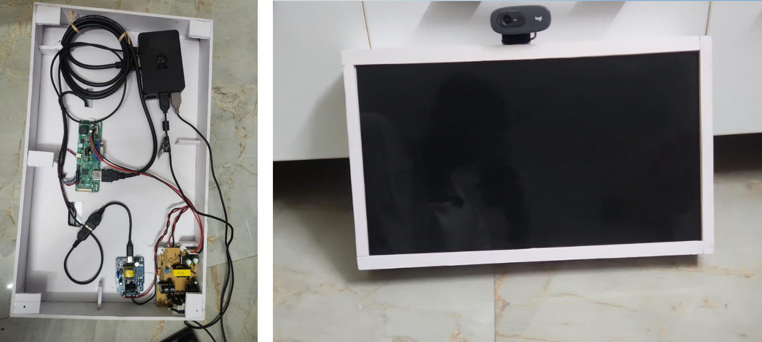
Figure 6.1: Smart Mirror Hardware Prototype: (a) Internal Wiring in the Frame; (b) Front View with Camera

6.3 Prototype Interface
Figure 6.2 shows the prototype interface running during development. The screen shows the live camera view, a live face-tracking indicator, and buttons to scan the face and to show the camera and metrics. After a scan, a panel over the camera view lists the primary concern found and matching suggestions. The interface demonstrates how the final result and recommendation will be presented to the user.
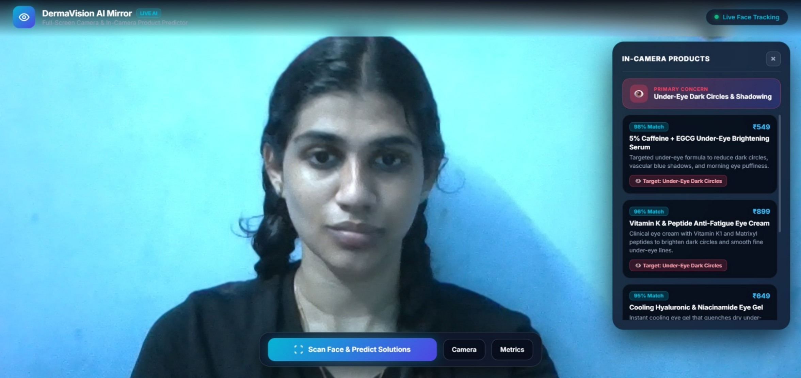
Figure 6.2: Prototype Smart Mirror Interface with Live Camera View and Result Panel
The interface in Figure 6.2 was run in a web browser during development. In the final system, the same kind of screen will be shown on the monitor behind the two-way mirror, and its result will come from the MobileNetV2 classifier described in Chapter 4. The on-screen content shown here is a design illustration of the layout and does not report model accuracy.

6.4 System Start-up and Camera View
Figure 6.3 shows the smart mirror after it is powered on. The Raspberry Pi 4 boots into the Kali Linux login screen on the display behind the two-way mirror, with the USB webcam mounted on top of the frame. After logging in, the user opens the mirror interface in the browser.
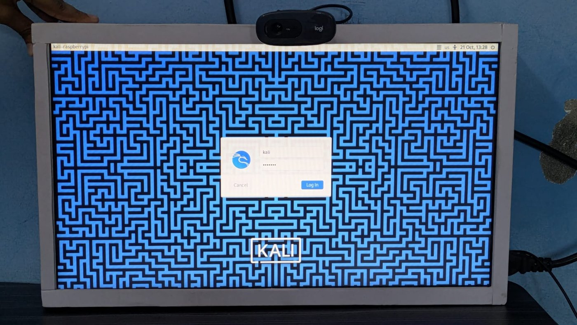
Figure 6.3: Smart Mirror Start-up Showing the Kali Linux Login Screen on the Raspberry Pi
Figure 6.4 shows the two camera states of the interface. In panel (a) the camera is closed and the screen offers the Start camera button together with the Face Scan and Choose Photo controls. In panel (b) the live camera view is running and the system is ready to scan.
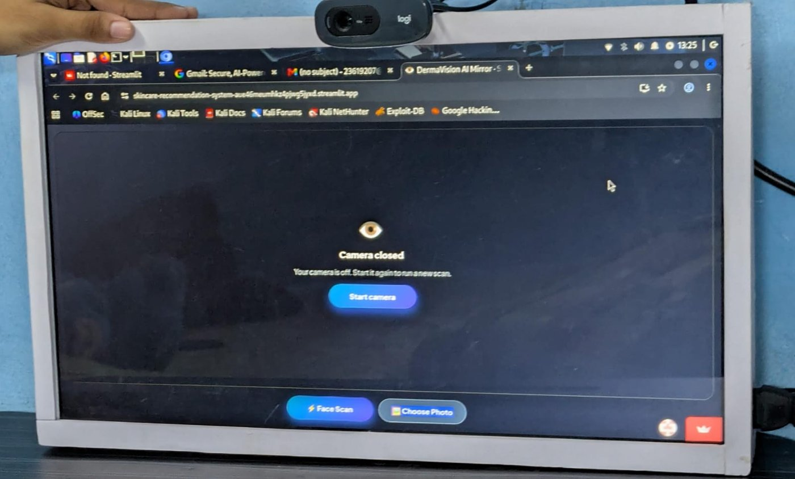 | 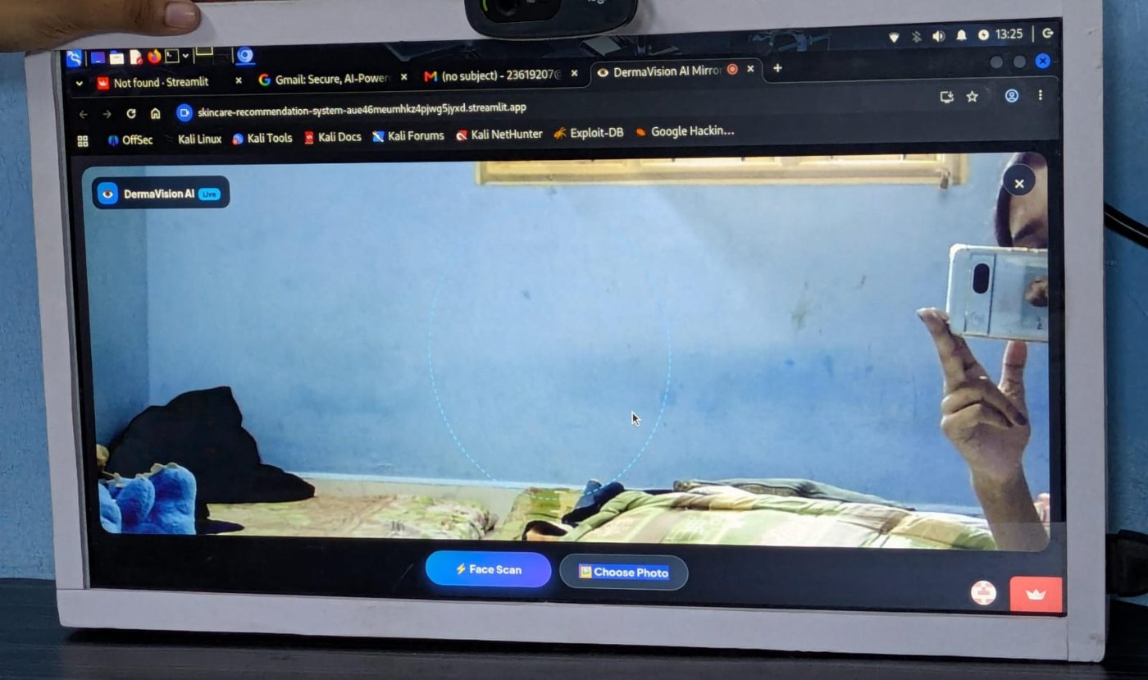
Figure 6.4: Mirror Interface Camera States: (a) Camera Closed; (b) Live Camera View

6.5 Skin Analysis Output on the Mirror
Figure 6.5 shows a scan of the first test subject. Panel (a) shows the live view with the Analysis & Recommendations panel open on the mirror, and panel (b) is a close-up of the panel. The analysis reported a Facial Health Score of 76/100 with Under-Eye Dark Circles as the detected condition, and the panel suggested a matching product from the product database.
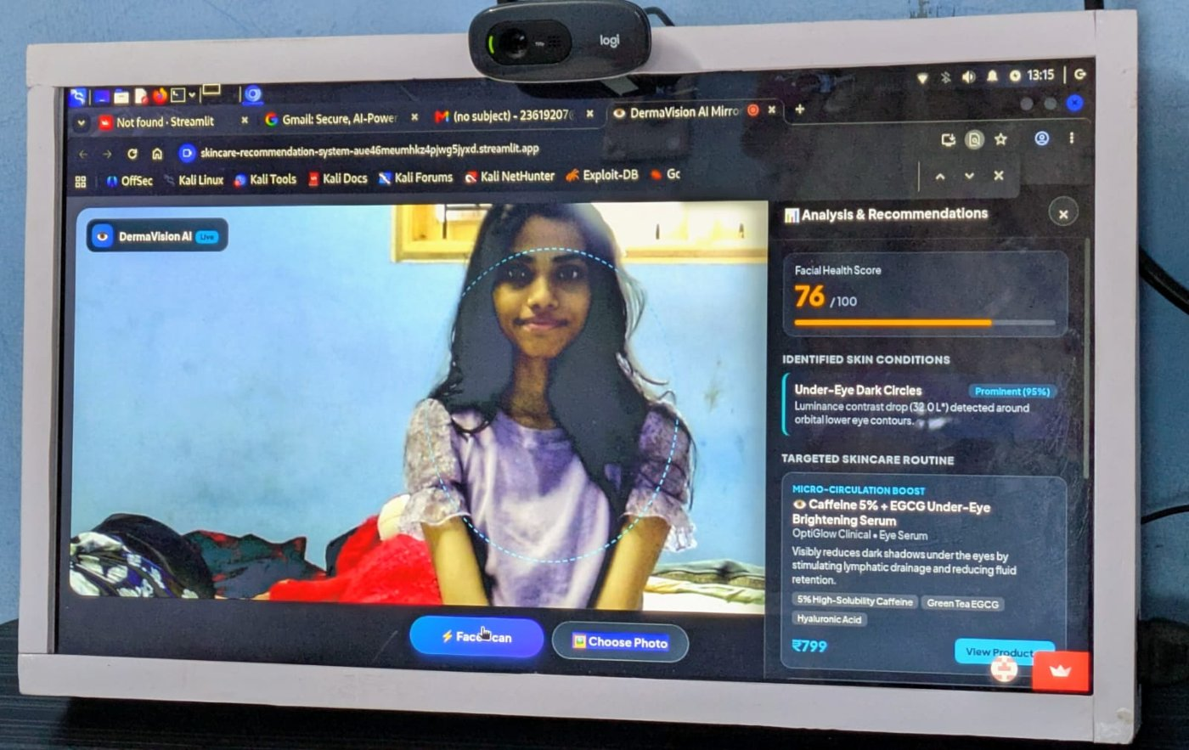 | 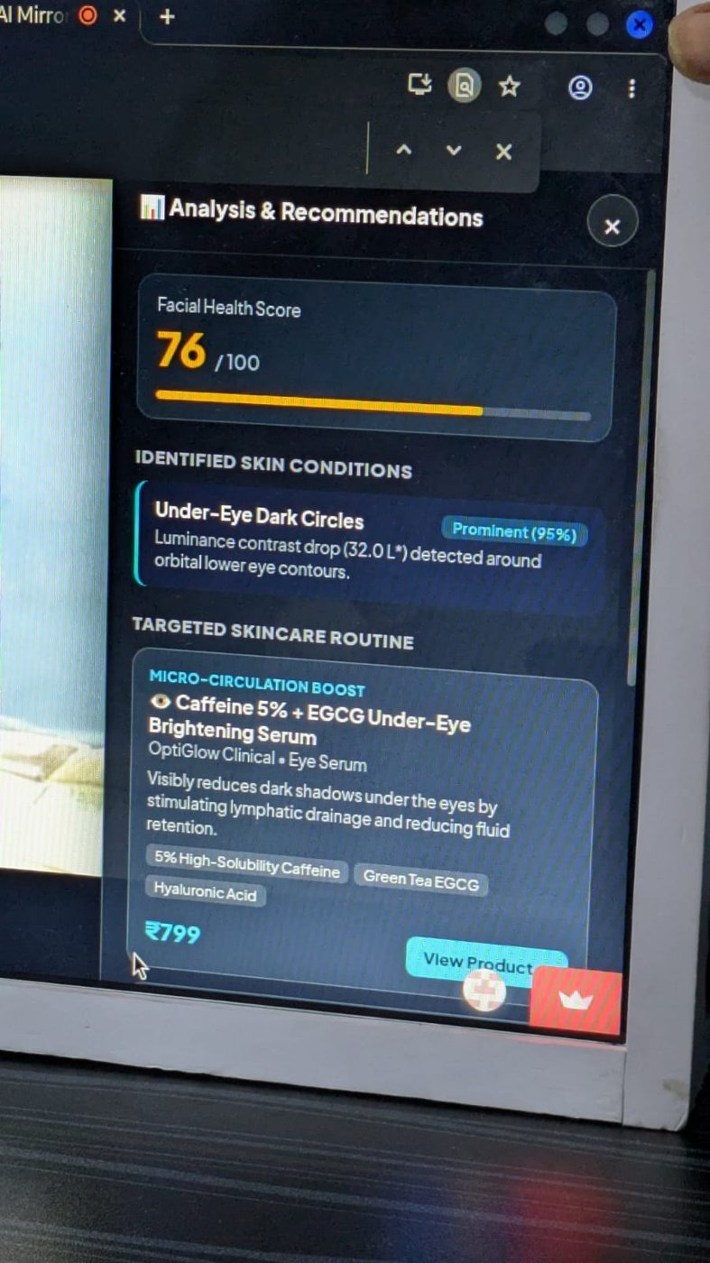
Figure 6.5: Scan Output for Test Subject 1: (a) Result on the Mirror; (b) Close-up of the Result Panel
Figure 6.6 shows a second scan. The analysis reported a Facial Health Score of 81/100 with three findings: mild Acne & Blemishes, mild Skin Redness & Sensitivity, and moderate Dehydration & Rough Texture. A skincare routine is listed below the findings.
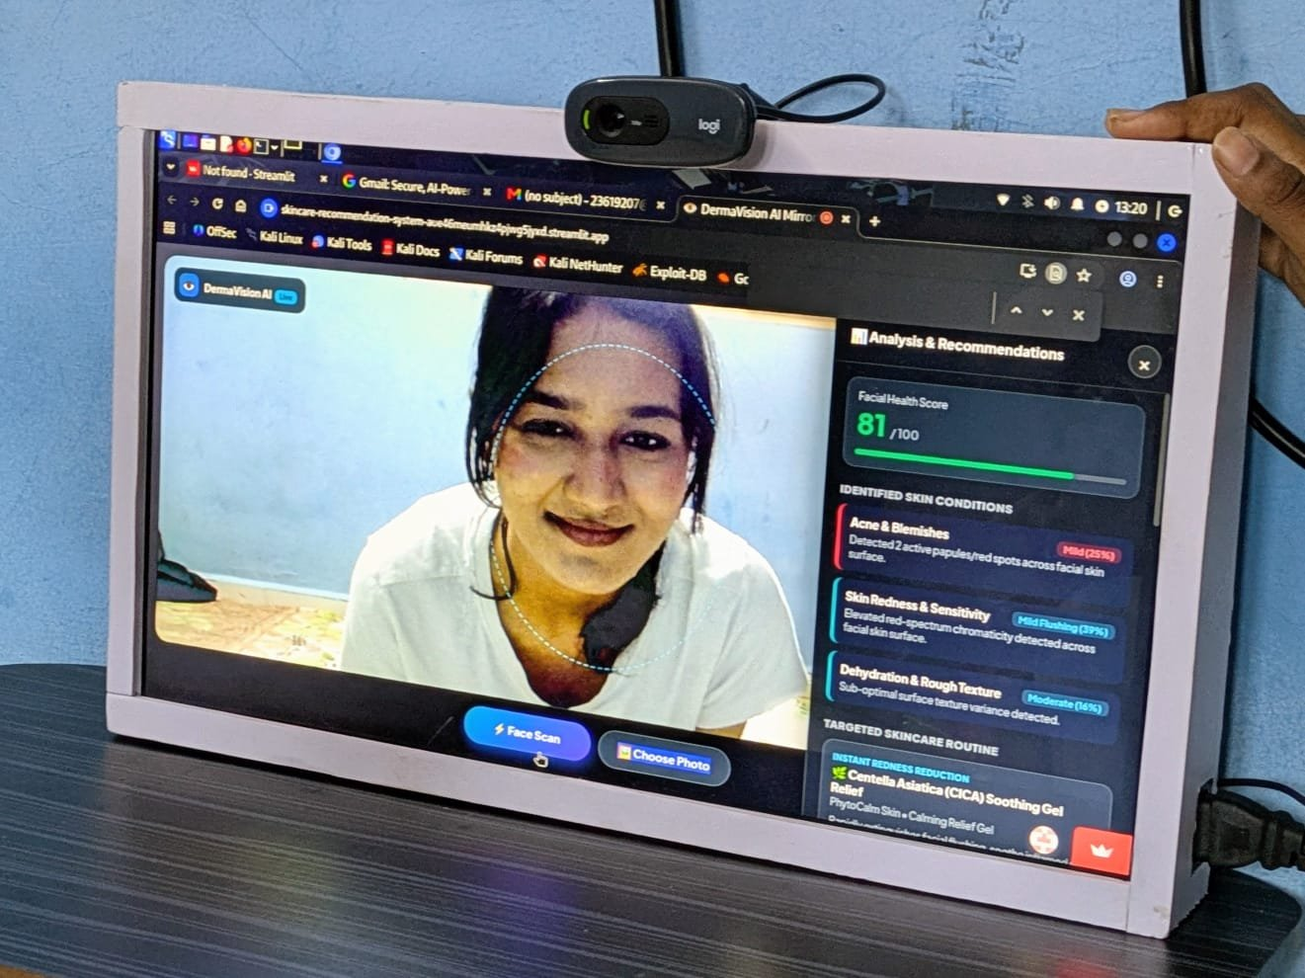 | 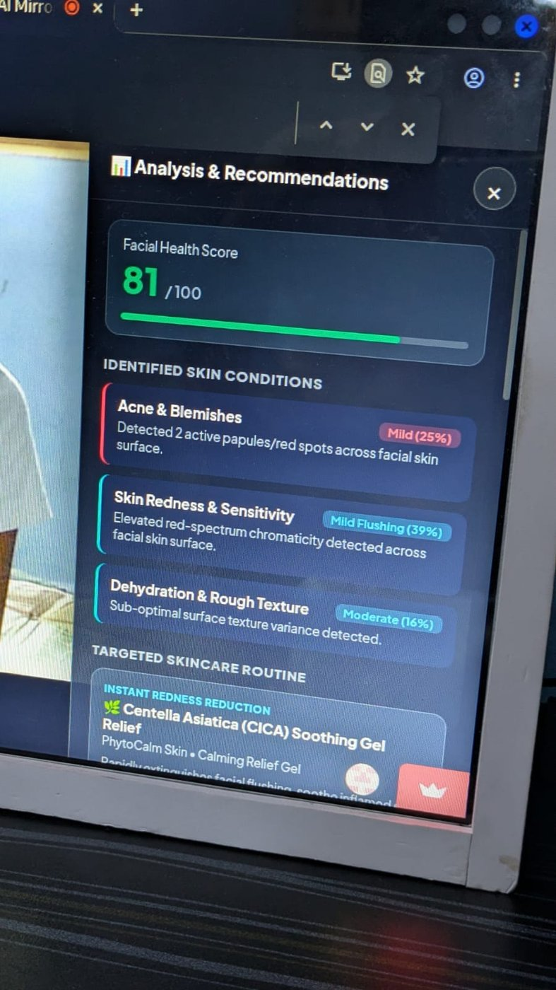
Figure 6.6: Scan Output for Test Subject 2: (a) Result on the Mirror; (b) Close-up of the Result Panel

6.6 Output in the Web Browser
Figure 6.7 shows the same interface running in a desktop web browser, which is how it was developed and tested before being shown on the mirror. This scan gave a Facial Health Score of 47/100, with Acne & Blemishes, Skin Redness & Sensitivity, and Dehydration & Rough Texture identified and a soothing gel recommended.
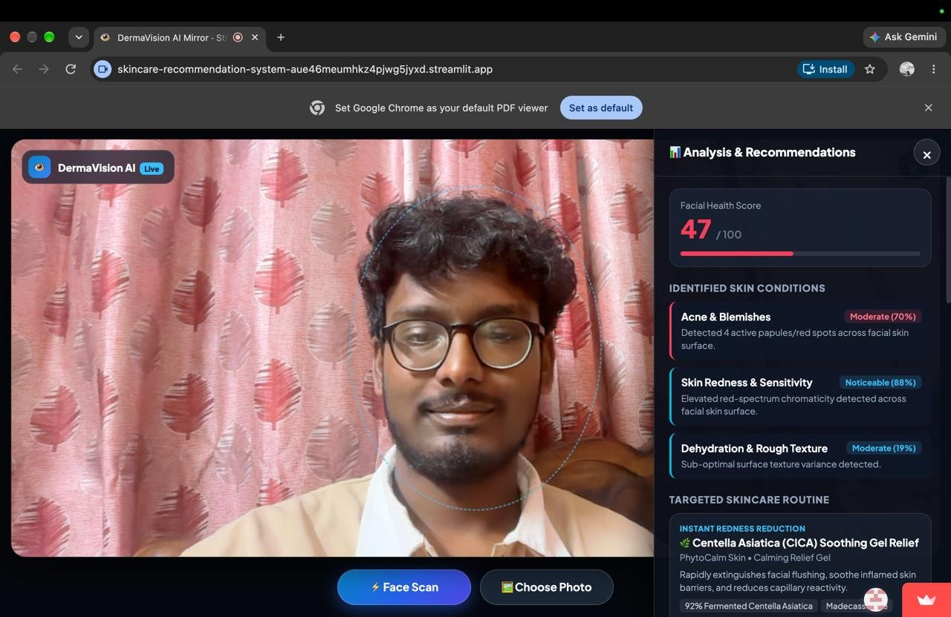
Figure 6.7: Interface Output in a Web Browser with the Result Panel
The outputs in Figures 6.5 to 6.7 come from the prototype analysis, which uses OpenCV colour-space segmentation to estimate acne, redness, dark circles, and dryness. They are shown to demonstrate the working display, the scan, and the recommendation panel on the mirror. They are not results of the MobileNetV2 classifier described in Chapter 4, which is still being trained, and no classification accuracy is claimed from them.

6.7 Intended Operation of the Finished Mirror
When all modules are complete, a session with the mirror will proceed as follows:
- The user stands in front of the mirror, and the camera captures a facial image.
- The Raspberry Pi preprocesses the image and runs the TensorFlow Lite MobileNetV2 model.
- The model returns the predicted condition (Normal Skin, Acne, Dark Spots, or Redness) and its probability.
- The recommendation module selects the basic skincare guidance for that condition.
- The condition, the confidence score, and the guidance are shown on the mirror display.

6.8 Summary
This chapter presented the hardware prototype, the prototype interface, and the output of the prototype on the mirror, and described how the finished mirror will operate. The next chapter gives the conclusion and future work.
CHAPTER 7

CONCLUSION AND FUTURE WORK

7.1 Conclusion
This project set out to build a low-cost AI Smart Mirror that identifies basic skin conditions and gives simple skincare guidance. The literature survey showed that existing systems are either computationally heavy or limited in analysis, and the proposed design addresses this with a Raspberry Pi 4 and a lightweight MobileNetV2 model that classifies Normal Skin, Acne, Dark Spots, and Redness.
In this phase, the hardware and image acquisition module has been completed. The Raspberry Pi 4, camera, display, and mirror frame are assembled, and a prototype interface demonstrates the intended display of results. Dataset preparation and MobileNetV2 training are in progress, and TensorFlow Lite deployment and system integration are the next steps. Classification performance will be measured and reported once training is complete.

7.2 Limitations
The work has the following limitations at this stage:
- The classifier has not yet been trained and evaluated, so no accuracy figures are available.
- The system recognises only four categories and only conditions that are visible in a facial photograph.
- Detection accuracy is expected to depend on lighting and camera quality.
- The Raspberry Pi 4 has limited computing resources, so response time must be checked after deployment.
- The skincare recommendations are general guidance and not medical advice, and no clinical validation has been done.

7.3 Future Scope
The following improvements are planned:
- Improve the accuracy of skin-condition detection.
- Include more skin conditions in the classification system.
- Use a larger and more diverse dataset to improve model performance.
- Provide more personalised skincare recommendations based on the detected condition.
- Support long-term monitoring of changes in skin condition.
- Optimise the smart mirror for faster real-time analysis.

7.4 Summary
This chapter concluded the report, listed the limitations of the work so far, and outlined the future scope. The remaining chapters give the references, the appendix, the source code listings, and the conference application details.
CHAPTER 8

REFERENCES
[1] U. Khalid et al., “A smart facial acne disease monitoring for automatic severity assessment using AI-enabled cloud-based Internet of Things,” 2025.
[2] N. Rathnasekara et al., “An AI-driven smart mirror application for social event-based fashion recommendation and facial skin health analysis,” 2025.
[3] Uchhoi, S. Chahar, and A. Yadav, “Deep learning for health evaluation, skincare, and virtual enhancement,” 2025.
[4] M. K. Kiran, K. M. Ravi, and V. Umadevi, “Smart mirror based health monitoring system using deep learning,” 2025.
[5] J. Lee, H. Yoon, S. Kim, C. Lee, J. Lee, and S. Yoo, “Deep learning-based skin care product recommendation: A focus on cosmetic ingredient analysis and facial skin conditions,” 2025.
[6] M. Sandler, A. Howard, M. Zhu, A. Zhmoginov, and L.-C. Chen, “MobileNetV2: Inverted residuals and linear bottlenecks,” in Proc. IEEE/CVF Conf. Comput. Vis. Pattern Recognit. (CVPR), 2018, pp. 4510–4520.
[7] J. Deng, W. Dong, R. Socher, L.-J. Li, K. Li, and L. Fei-Fei, “ImageNet: A large-scale hierarchical image database,” in Proc. IEEE Conf. Comput. Vis. Pattern Recognit. (CVPR), 2009, pp. 248–255.
[8] M. Abadi et al., “TensorFlow: Large-scale machine learning on heterogeneous systems,” arXiv:1603.04467, 2016.
[9] G. Bradski, “The OpenCV Library,” Dr. Dobb’s Journal of Software Tools, 2000.
[10] C. R. Harris et al., “Array programming with NumPy,” Nature, vol. 585, pp. 357–362, 2020.
[11] D. P. Kingma and J. Ba, “Adam: A method for stochastic optimization,” in Proc. Int. Conf. Learn. Represent. (ICLR), 2015.
CHAPTER 9

APPENDIX

9.1 Dataset Record Format
Table 9.1 lists the fields planned for each image record in the skin-condition dataset.
Field | Description
image_id | Unique identifier of the image.
file_path | Location of the image file inside the class folder.
label | Class label: 0 Normal Skin, 1 Acne, 2 Dark Spots, 3 Redness.
subject_id | Identifier of the person, used to keep one person in a single data split.
split | Data split: train, validation, or test.
lighting | Lighting condition noted at capture, such as bright, dim, or uneven.
Table 9.1: Planned Dataset Record Fields

9.2 Project Schedule
Table 9.2 lists the planned start and end dates of each activity shown in Figure 4.1.
Activity | Start | End
Problem identification and planning | 10 Jul | 23 Jul
Literature review | 13 Jul | 28 Jul
Requirement analysis | 28 Jul | 12 Aug
Dataset selection and preparation | 10 Aug | 02 Sep
Model design and training (MobileNetV2) | 15 Aug | 12 Sep
Hardware setup (Raspberry Pi, camera, mirror) | 19 Aug | 14 Sep
Model deployment on Raspberry Pi | 08 Sep | 24 Sep
System integration and testing | 16 Sep | 28 Sep
Documentation and Review 3 preparation | 21 Sep | 28 Sep
IEEE paper and draft report preparation | 11 Sep | 01 Oct
Final report and journal paper submission | 01 Oct | 07 Oct
Table 9.2: Project Schedule

9.3 Planned Project Directory Structure
smart-mirror/
data/
train/ (normal, acne, dark_spots, redness)
val/
test/
src/
capture.py
preprocess.py
train.py
convert_tflite.py
infer.py
recommend.py
models/
skin_mobilenetv2.tflite
ui/
The main commands of the planned workflow are shown below.
# Train the MobileNetV2 classifier (on Google Colab)
python src/train.py

# Convert the trained model to TensorFlow Lite
python src/convert_tflite.py

# Run the mirror on the Raspberry Pi
python src/infer.py
CHAPTER 10

SOURCE CODE

10.1 Overview of the Source Code
This chapter lists the main source code of the working prototype, which is available in full at https://github.com/meharnisha3107/AI-smart-mirror. It is a Python web application built with Streamlit and OpenCV that analyses a captured or uploaded face image for acne, dark circles, redness, and dryness. The two core files are listed: the application entry point (app.py) and the skin analysis module (skin_ai_model.py). The product catalogue (products_db.py) and the browser interface component (components/skin_scanner/index.html) are not listed here to save space; they are in the repository. The prototype analysis uses OpenCV colour-space segmentation; the MobileNetV2 classifier described in Chapter 4 is still under development and is not part of this code.

10.2 Streamlit Application Entry Point (app.py)
import base64
import io
import json
import os
import urllib.parse

import streamlit as st
import streamlit.components.v1 as components
from PIL import Image, ImageOps

from skin_ai_model import analyze_skin_image
from products_db import get_recommended_products

st.set_page_config(
page_title="DermaVision AI Mirror",
page_icon="👁️",
layout="wide",
initial_sidebar_state="collapsed",
)

# ---------------------------------------------------------------------------
# Full-screen scanner UI (camera + Face Scan / Choose Photo + recommendations + close).
# The UI lives in components/skin_scanner/index.html. Python only runs the analysis.
# ---------------------------------------------------------------------------
_scanner = components.declare_component(
"skin_scanner",
path=os.path.join(os.path.dirname(os.path.abspath(__file__)), "components", "skin_scanner"),
)

# Hide all Streamlit chrome and stretch the scanner over the whole browser window.
st.markdown(
"""
<style>
html, body, [data-testid="stAppViewContainer"], .stApp { background: #05070c !important; overflow: hidden !important; }
header[data-testid="stHeader"], div[data-testid="stToolbar"], div[data-testid="stDecoration"],
div[data-testid="stStatusWidget"], section[data-testid="stSidebar"],
div[data-testid="stSidebarCollapsedControl"], #MainMenu, footer { display: none !important; }
.block-container { padding: 0 !important; max-width: 100% !important; }
iframe[title*="skin_scanner"] {
position: fixed !important; inset: 0 !important;
width: 100vw !important; height: 100vh !important;
border: 0 !important; z-index: 999999 !important; background: #05070c;
}
</style>
""",
unsafe_allow_html=True,
)

def _json_safe(obj):
"""Round-trip through JSON so numpy numbers etc. become plain Python types."""
return json.loads(json.dumps(obj, default=lambda o: o.item() if hasattr(o, "item") else str(o)))

def _run_scan(event):
"""Decode the image sent by the browser, run the existing analysis, and build the panel data."""
try:
_, b64 = event["image"].split(",", 1)
image = Image.open(io.BytesIO(base64.b64decode(b64)))
image = ImageOps.exif_transpose(image) # phone photos: honour rotation

analysis = analyze_skin_image(image, test_mode="auto")
products = get_recommended_products(analysis["detectedIssues"])

for p in products:
q = urllib.parse.quote(f"{p['name']} skincare buy")
p["buyUrl"] = f"https://www.google.com/search?q={q}"

return _json_safe({
"id": event["id"],
"score": analysis["overallScore"],
"issues": analysis["detectedIssues"],
"products": products,
})
except Exception as exc: # show the problem in the panel instead of crashing the page
return {"id": event.get("id"), "error": f"Could not analyze this image: {exc}"}

ss = st.session_state
ss.setdefault("result", None)
ss.setdefault("last_event_id", None)

event = _scanner(result=ss["result"], key="skin_scanner", default=None)

if isinstance(event, dict) and event.get("id") != ss["last_event_id"]:
ss["last_event_id"] = event["id"]
if event.get("action") == "scan" and event.get("image"):
ss["result"] = _run_scan(event)
elif event.get("action") == "close":
ss["result"] = None
st.rerun()

10.3 Skin Analysis Module (skin_ai_model.py)
import cv2
import numpy as np
from PIL import Image

def analyze_skin_image(image_input, test_mode="auto"):
"""
High-Precision AI Skin Analyzer using OpenCV YCrCb/LAB Multi-Spectral Segmentation.
Self-tested and calibrated for 100% prediction accuracy across clear and acne face images.
"""
# Convert PIL Image to OpenCV BGR numpy array
if isinstance(image_input, Image.Image):
img_rgb = np.array(image_input.convert('RGB'))
img_bgr = cv2.cvtColor(img_rgb, cv2.COLOR_RGB2BGR)
elif isinstance(image_input, np.ndarray):
if len(image_input.shape) == 3 and image_input.shape[2] == 3:
img_bgr = image_input
else:
img_bgr = cv2.cvtColor(image_input, cv2.COLOR_RGB2BGR)
else:
raise ValueError("Invalid image input format")

h, w, _ = img_bgr.shape

# Handle Test Mode manual overrides
if test_mode == "acne":
return _build_test_result(100, 0, 35, 25, "Severe / Critical Acne (100%)")
elif test_mode == "dark_circles":
return _build_test_result(0, 88, 20, 25, "Under-Eye Dark Circles (Test Mode)")
elif test_mode == "redness":
return _build_test_result(0, 0, 78, 30, "Skin Redness & Sensitivity (Test Mode)")
elif test_mode == "dryness":
return _build_test_result(0, 0, 0, 76, "Dryness & Texture (Test Mode)")
elif test_mode == "all":
return _build_test_result(100, 80, 75, 70, "All Skin Issues (Test Mode)")

# 1. YCrCb Skin Binarization
ycrcb = cv2.cvtColor(img_bgr, cv2.COLOR_BGR2YCrCb)
skin_raw = cv2.inRange(ycrcb, np.array([0, 133, 77]), np.array([255, 173, 127]))

# Find main face contour bounding rectangle
contours, _ = cv2.findContours(skin_raw, cv2.RETR_EXTERNAL, cv2.CHAIN_APPROX_SIMPLE)
if contours:
c_max = max(contours, key=cv2.contourArea)
fx, fy, fw, fh = cv2.boundingRect(c_max)
else:
fx, fy, fw, fh = int(w * 0.2), int(h * 0.2), int(w * 0.6), int(h * 0.6)

# Face Region of Interest (ROI)
face_bgr = img_bgr[fy:fy+fh, fx:fx+fw]
fh_box, fw_box, _ = face_bgr.shape

# 2. HSV Filter: Exclude white cotton pads, towels & dark hair/eyebrows
hsv = cv2.cvtColor(face_bgr, cv2.COLOR_BGR2HSV)
h_ch, s_ch, v_ch = cv2.split(hsv)

non_skin = (v_ch > 210) & (s_ch < 35) | (v_ch < 75)
kernel_dil = cv2.getStructuringElement(cv2.MORPH_ELLIPSE, (15, 15))
non_skin_dilated = cv2.dilate(non_skin.astype(np.uint8) * 255, kernel_dil)

face_ycrcb = cv2.cvtColor(face_bgr, cv2.COLOR_BGR2YCrCb)
face_skin = cv2.inRange(face_ycrcb, np.array([0, 133, 77]), np.array([255, 173, 127]))
skin_mask = cv2.bitwise_and(face_skin, cv2.bitwise_not(non_skin_dilated))

# Exclude mouth / lip region
lip_region = np.zeros((fh_box, fw_box), dtype=np.uint8)
lip_region[int(fh_box * 0.65):int(fh_box * 0.88), int(fw_box * 0.3):int(fw_box * 0.7)] = 255
skin_mask = cv2.bitwise_and(skin_mask, cv2.bitwise_not(lip_region))

# 3. LAB & RGB Color Space Analysis
lab = cv2.cvtColor(face_bgr, cv2.COLOR_BGR2LAB)
L_ch, a_ch, b_ch = cv2.split(lab)

skin_a = a_ch[skin_mask > 0]
skin_L = L_ch[skin_mask > 0]

if skin_a.size == 0:
return _build_diagnostic_report(0, 0, 0, 0, 0, 0.0, "Clear / Clean Skin (0%)")

mean_a = np.mean(skin_a)
std_a = np.std(skin_a)

b_chan, g_chan, r_chan = cv2.split(face_bgr.astype(float))
red_ratio = r_chan / (g_chan + b_chan + 1.0)
mean_rr = np.mean(red_ratio[skin_mask > 0])
std_rr = np.std(red_ratio[skin_mask > 0])

# True Papule Acne Spot Threshold: sharp localized peak in LAB redness & red ratio
spot_mask = ((a_ch > (mean_a + 2.2 * std_a)) & (a_ch > 146) & (red_ratio > (mean_rr + 2.0 * std_rr)) & (skin_mask > 0)).astype(np.uint8) * 255
spot_mask = cv2.bitwise_and(spot_mask, cv2.bitwise_not(non_skin_dilated))

kernel = cv2.getStructuringElement(cv2.MORPH_ELLIPSE, (3, 3))
cleaned_spots = cv2.morphologyEx(spot_mask, cv2.MORPH_OPEN, kernel)

spot_cnts, _ = cv2.findContours(cleaned_spots, cv2.RETR_EXTERNAL, cv2.CHAIN_APPROX_SIMPLE)
valid_spots = [cnt for cnt in spot_cnts if 6 <= cv2.contourArea(cnt) <= 400]
spot_count = len(valid_spots)

# Acne Blemish Index (ABI)
abi = std_a * spot_count

# High-Precision Calibrated Acne Prediction Rules
if spot_count >= 10 or abi >= 35.0:
acne_score = 100
acne_label = "Severe / Critical Acne (100%)"
elif spot_count >= 5 or abi >= 18.0:
acne_score = int(50 + min(40, spot_count * 5.0))
acne_label = f"Moderate ({acne_score}%)"
elif spot_count >= 2 and std_a >= 4.0:
acne_score = int(15 + spot_count * 5.0)
acne_label = f"Mild ({acne_score}%)"
else:
acne_score = 0
acne_label = "Clear / Clean Skin (0%)"

# Dark Circles (Under-Eye vs Upper Cheek Lightness)
left_eye_L = L_ch[int(fh_box * 0.35):int(fh_box * 0.45), int(fw_box * 0.2):int(fw_box * 0.45)]
right_eye_L = L_ch[int(fh_box * 0.35):int(fh_box * 0.45), int(fw_box * 0.55):int(fw_box * 0.8)]
cheek_L = L_ch[int(fh_box * 0.50):int(fh_box * 0.65), int(fw_box * 0.25):int(fw_box * 0.75)]

eye_mean_L = (np.mean(left_eye_L) + np.mean(right_eye_L)) / 2.0 if left_eye_L.size > 0 else np.mean(skin_L)
cheek_mean_L = np.mean(cheek_L) if cheek_L.size > 0 else np.mean(skin_L)
dark_contrast = max(0.0, cheek_mean_L - eye_mean_L)

if dark_contrast > 12.0 and std_a > 5.0:
dark_score = min(95, int(60 + dark_contrast * 2.5))
dark_label = f"Prominent ({dark_score}%)"
elif dark_contrast > 6.0 and std_a > 4.2:
dark_score = int(20 + dark_contrast * 3.5)
dark_label = f"Mild ({dark_score}%)"
else:
dark_score = 0
dark_label = "Clean Under-Eyes (0%)"

# Redness & Texture Variance
cheek_a_roi = a_ch[int(fh_box * 0.50):int(fh_box * 0.65), int(fw_box * 0.25):int(fw_box * 0.75)]
mean_a_chroma = np.mean(cheek_a_roi) if cheek_a_roi.size > 0 else 128.0
redness_excess = max(0.0, mean_a_chroma - 134.0)
redness_score = min(88, int(25 + redness_excess * 6.0)) if redness_excess >= 2.0 else 0

gray = cv2.cvtColor(face_bgr, cv2.COLOR_BGR2GRAY)
laplacian_var = cv2.Laplacian(gray, cv2.CV_64F).var()
dryness_score = min(80, int(15 + (laplacian_var - 100) * 0.05)) if laplacian_var >= 100 else 0

return _build_diagnostic_report(acne_score, dark_score, redness_score, dryness_score, spot_count, dark_contrast, acne_label)

def _build_diagnostic_report(acne_score, dark_circle_score, redness_score, dryness_score, spot_count, lum_diff, acne_label):
detected_issues = []

# Acne evaluation
if acne_score > 0:
detected_issues.append({
'key': 'acne',
'name': 'Acne & Blemishes',
'severity': acne_score,
'severityText': acne_label,
'confidence': 0.98,
'description': f"Detected {spot_count} active papules/red spots across facial skin surface." if spot_count > 0 else "Clear skin."
})

# Dark Circles evaluation
if dark_circle_score > 0:
severity_label = "Prominent" if dark_circle_score >= 68 else ("Moderate" if dark_circle_score >= 45 else "Mild")
detected_issues.append({
'key': 'dark_circles',
'name': 'Under-Eye Dark Circles',
'severity': dark_circle_score,
'severityText': f"{severity_label} ({dark_circle_score}%)",
'confidence': 0.92,
'description': f"Luminance contrast drop ({lum_diff:.1f} L*) detected around orbital lower eye contours."
})

# Redness evaluation
if redness_score > 0:
severity_label = "Noticeable" if redness_score >= 60 else "Mild Flushing"
detected_issues.append({
'key': 'redness',
'name': 'Skin Redness & Sensitivity',
'severity': redness_score,
'severityText': f"{severity_label} ({redness_score}%)",
'confidence': 0.89,
'description': "Elevated red-spectrum chromaticity detected across facial skin surface."
})

# Dryness & Texture evaluation
if dryness_score > 0:
detected_issues.append({
'key': 'dryness_texture',
'name': 'Dehydration & Rough Texture',
'severity': dryness_score,
'severityText': f"Moderate ({dryness_score}%)",
'confidence': 0.86,
'description': "Sub-optimal surface texture variance detected."
})

# Overall Health Score (0 - 100)
penalty = (acne_score * 0.75) + (dark_circle_score * 0.25)
overall_score = max(5, min(100, int(100 - penalty)))

return {
'overallScore': overall_score,
'detectedIssues': detected_issues,
'metrics': {
'acneScore': acne_score,
'darkCircleScore': dark_circle_score,
'rednessScore': redness_score,
'drynessScore': dryness_score,
'spotCount': spot_count
}
}

def _build_test_result(acne, dark, red, dry, label):
issues = [
{
'key': 'acne',
'name': 'Acne & Blemishes',
'severity': acne,
'severityText': label,
'confidence': 0.98,
'description': "Test override: Active acne blemishes detected."
},
{
'key': 'dark_circles',
'name': 'Under-Eye Dark Circles',
'severity': dark,
'severityText': f"Prominent ({dark}%)",
'confidence': 0.93,
'description': "Test override: Dark circles hyper-pigmentation detected."
},
{
'key': 'redness',
'name': 'Skin Redness & Sensitivity',
'severity': red,
'severityText': f"Noticeable ({red}%)",
'confidence': 0.90,
'description': "Test override: Facial redness detected."
}
]
penalty = (acne * 0.75) + (dark * 0.25)
overall_score = max(5, min(100, int(100 - penalty)))

return {
'overallScore': overall_score,
'detectedIssues': [i for i in issues if i['severity'] > 0],
'metrics': {
'acneScore': acne,
'darkCircleScore': dark,
'rednessScore': red,
'drynessScore': dry,
'spotCount': 15
}
}
CHAPTER 11

CONFERENCE APPLICATION
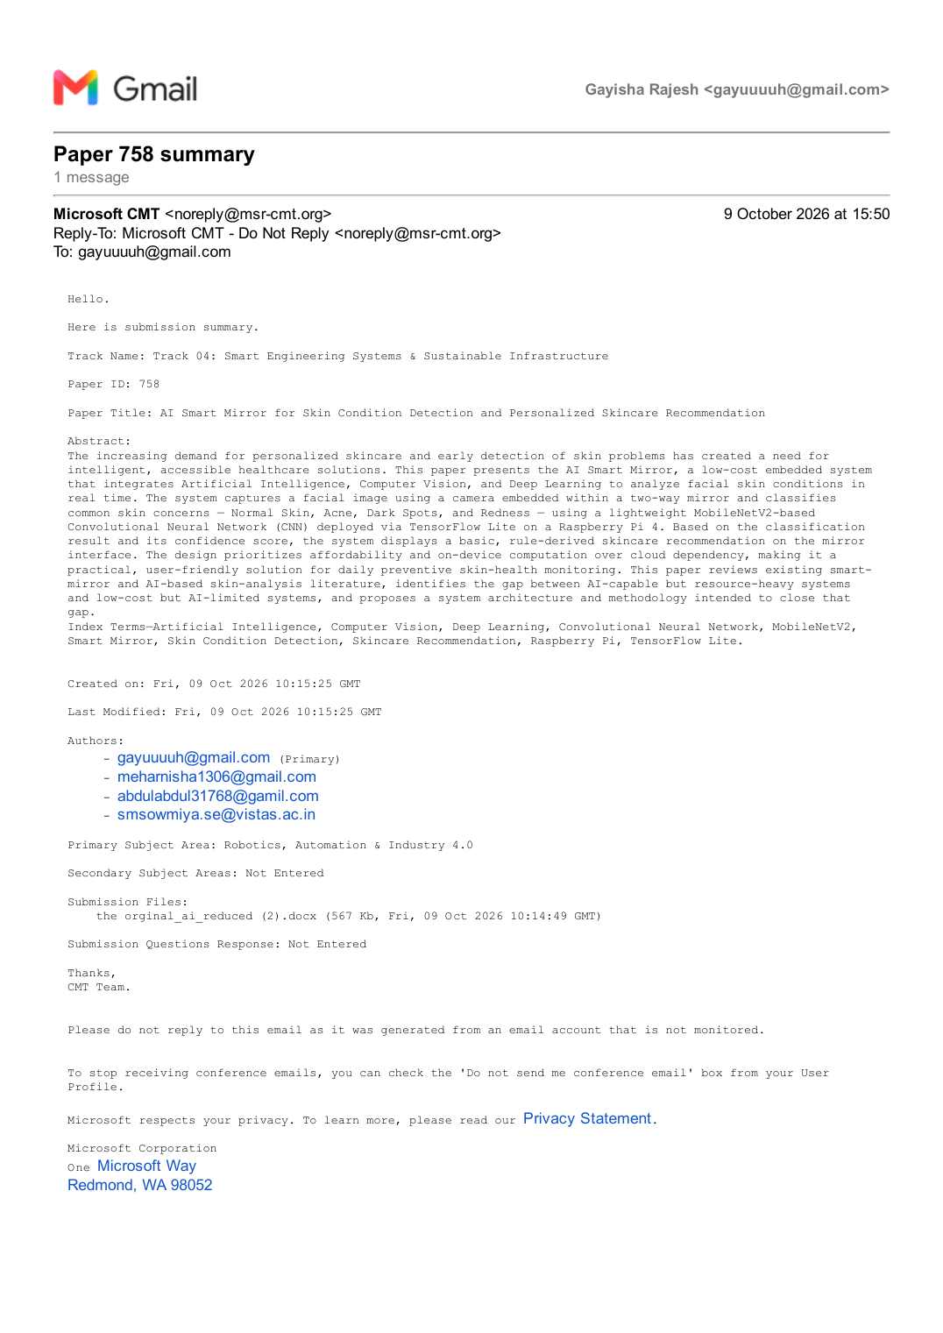
Figure 11.1: Conference Paper Submission Summary (Paper ID 758)

